Part C — Individual Implementation

Pathirana P P D S S — IT23534254
Group 18 · SE3070 Case Studies in Software Engineering · Assignment 02 · DEWECS. Drafted 7 October 2026; every figure and count was read from the repository, the test reports and the JaCoCo output of the same build.
AUTHOR NOTE (delete before submitting): text in red marks the items only you can supply or confirm: Flutter screenshots (C.3), who covers UC-05 (C.1), branch and repository visibility (C.6), a fresh flutter test run (C.5.4), Phase 1–5 prompts and hand edits (Appendix C-A). Parts A and B of the group report were also drafted with Claude, so the group should log those prompts too.
Corrected use cases implemented | UC-01, UC-02 (officer review plus citizen reporting through a REST API and a Flutter app), UC-03 and UC-04. UC-05 is not part of this implementation (C.1, C.7).
Stack | Java 21, Spring Boot 3.5.16 (Spring MVC, Thymeleaf, Spring Data JPA, Bean Validation), PostgreSQL on Neon and in-memory H2, Maven. Flutter (Dart) for the Android citizen app.
Backend tests | 154 passing, 0 failing, 0 skipped (31 test classes; JUnit 5, Mockito, MockMvc, @Data​Jpa​Test).
Line coverage (JaCoCo) | UC-01 90.3% · UC-02 web 97.6% · UC-02 API 94.3% · UC-03 86.5% · UC-04 88.4% · whole project 81.8% (each use case above 80%).
Repository | https://github.com/dilmithp/se3070-group18-dewecs (backend/​ Spring Boot, mobile/​ Flutter, doc/​ contract, demo script and screenshots). Branch: VERIFY — submit main after merging dev; see C.6

C.1 Use case implemented (corrected design)
This repository implements four of the five use cases in Part B’s corrected numbering, plus the citizen-facing half of UC-02. IDs and names follow Part B, Improvement 1 (point 3).
ID | Corrected use case | Implemented as | Status
UC-01 | Issue and Escalate Hazard Warning | Warning console at /​warnings: create a draft, edit it, publish, retract, automatic expiry, filter by status and region. | Implemented, except escalation (alternate flow A2). See C.7.
UC-02 | Manage Ground Reports | Officer review at /​ground-reports (mark reviewed, action with a note, dismiss), and the citizen side: a JSON API under /​api/​v1 and the Flutter app “DEWECS Report” with an offline queue. | Implemented, except the needs-more-information outcome and the link to UC-01. See C.7.
UC-03 | Coordinate Shelter and Rescue Operations | Shelters with capacity and occupant check-in and check-out (/​shelters); rescue requests with team assignment (/​rescue-requests). | Implemented, except offline resync, nearest-team choice and cross-organisation dispatch. See C.7.
UC-04 | Coordinate Relief Distribution | Relief supplies with restock and a low-stock flag (/​relief-supplies); distributions with dispatch, delivery and cancellation (/​relief-distributions). | Implemented.
UC-05 | Generate Post-Event Analysis Report | Not built. Post​Event​Report and Report​Metric exist only as domain classes with bare repositories. | Not implemented here.  CONFIRM — which member covers UC-05

Out of scope under the assignment: login/logout and administrative-privilege functions. Officers are chosen from drop-downs, and 26 TODO comments mark the actions that will need a role check once authentication exists. Warning delivery (SMS, push, siren) is stored as a channel selection only (C.7, G4).

C.2 Implementation summary

C.2.1 Approach and stack
The backend is a layered Spring Boot application. Thin Thymeleaf controllers call one service interface per use case. The business rules live in the service/impl classes, Spring Data JPA repositories store the entities, and DTOs (*FormRequest for input, *Response for output) with mappers keep entities out of the views. Each aggregate has its own validation exception; one GlobalExceptionHandler turns exceptions into an HTML error page for browsers and an RFC 7807 problem+json body for /api/**. Everything is constructor-injected, so each service is unit-tested with mocked repositories. Pages follow post/redirect/get with a flash message for success or for a broken rule.
Layer | Technology
Language and build | Java 21, Maven (no wrapper: use mvn).
Framework | Spring Boot 3.5.16: Spring MVC, Spring Data JPA (Hibernate 6), Bean Validation. No Lombok.
Views | Thymeleaf with shared fragments (head, nav, page​Header, flash, badge), one stylesheet built on design tokens, one 10-line script for confirm dialogs, inline SVG icons. No CDN and no JavaScript framework; every page works with JavaScript off.
Database | PostgreSQL on Neon (default and dev profiles, settings read from environment variables); in-memory H2 for the local demo profile and for all tests.
Citizen app | Flutter (Dart), Android only. Provider with Change​Notifier, an offline queue and sync engine, talking to the backend over HTTP only (contract v1).
Quality tools | JUnit 5, Mockito, Spring MockMvc, @Data​Jpa​Test, JaCoCo 0.8.12; flutter test and a smoke script for the app.

C.2.2 Key classes and endpoints per use case
Use case | Controller and routes | Service (interface → implementation) | Supporting classes
UC-01 | Warning​Controller  /​warnings, /​warnings/​new, /​warnings/​{id}, /​{id}/​edit  POST /​{id}/​publish, /​{id}/​retract | Warning​Service  → Warning​Service​Impl | Warning​Form​Request, Warning​Response, Warning​Mapper, Warning​Validation​Exception  Entities Warning, Hazard​Event; enums Warning​Status, Severity, Broadcast​Channel
UC-02 web | Ground​Report​Controller  /​ground-reports, /​ground-reports/​{id}  POST /​{id}/​review, /​{id}/​action, /​{id}/​dismiss | Ground​Report​Service  → Ground​Report​Service​Impl | Ground​Report​Response, Ground​Report​Mapper, Ground​Report​Validation​Exception  Entity Ground​Report; enum Ground​Report​Status
UC-02 API | Reference​Data​Api​Controller, Citizen​Api​Controller, Ground​Report​Api​Controller, Photo​Api​Controller  All under /​api/​v1 (C.2.4) | Citizen​Service → Citizen​Service​Impl  Ground​Report​Submission​Service → Ground​Report​Submission​Service​Impl  Photo​Storage​Service → File​System​Photo​Storage​Service | Seven records in dto/​api, Ground​Report​Api​Mapper, Citizen​Validation​Exception  Clock​Config (Asia/Colombo), Api​Cors​Config, Jackson​Config
UC-03 | Shelter​Controller  /​shelters (+ new, {id}, edit); POST close, reopen, check-in, check-out/​{occupant​Id}  Rescue​Request​Controller  /​rescue-requests (+ new, {id}); POST assign, complete, cancel | Shelter​Service → Shelter​Service​Impl  Rescue​Request​Service → Rescue​Request​Service​Impl | Shelter​Form​Request, Check​In​Request, Rescue​Request​Form​Request, the response DTOs, two mappers, two validation exceptions  Entities Shelter, Shelter​Occupant, Rescue​Team, Rescue​Request
UC-04 | Relief​Supply​Controller  /​relief-supplies (+ new, {id}, edit); POST restock  Relief​Distribution​Controller  /​relief-distributions (+ new, {id}); POST deliver, cancel | Relief​Supply​Service → Relief​Supply​Service​Impl  Relief​Distribution​Service → Relief​Distribution​Service​Impl | Relief​Supply​Form​Request, Restock​Request, Relief​Distribution​Form​Request, response DTOs, two mappers, Relief​Validation​Exception  Entities Resource, Relief​Consignment, Consignment​Item
Shared | Dashboard​Controller  /​ and /​dashboard | Dashboard​Service → Dashboard​Service​Impl | Dashboard​Summary; Global​Exception​Handler, Resource​Not​Found​Exception; Demo​Data​Loader (local profile only)

C.2.3 How the implementation follows Part B
Part B changed the use case diagram, the class and sequence diagrams and the scenario documents. The table lists each change that touches the implementation and what the code does about it.
# | Part B change | In the implementation | Status
1 | Improvement 1, point 1: escalation is alternate flow A2 of UC-01, not a use case of its own. | There is one warning use case (Warning​Service) and no separate escalate use case or screen. The escalation behaviour itself is not built (C.7, G1). | Partly
2 | Improvement 1, point 2 and Improvement 2: split UC-002 into UC-04 (live distribution) and UC-05 (post-event report). | Distribution is its own service (Relief​Distribution​Service) with no reporting code. Post​Event​Report and Report​Metric are untouched. UC-05 itself is not built (G5). | Partly
3 | Improvement 1, point 3: one ID scheme, UC-01 to UC-05. | This report uses UC-01 to UC-05 throughout. | Followed
4 | Improvement 1, point 4: named extension points (UC-01 on critical verification; UC-04 on escalation). | Not implemented: a verified report does not create or suggest a warning (G3), and UC-04 has nothing to hook into until escalation exists (G1). | Not implemented
5 | Improvement 2: Shelter and Rescue​Team gain an Organization association. | Shelter.​organization and Rescue​Team.​organization are required many-to-one associations. A shelter is created with its owning organization and lists it (Figures C-5 to C-7). | Followed
6 | Improvement 2: document Shelter​Occupant check-in and check-out across the artifacts. | Shelter​Service​Impl.​check​In and check​Out, the check-in form and the occupant table with Check out (Figure C-7); tests in C.5.3. | Followed
7 | Improvement 2: Post​Event​Report gains associations to Warning/Notification and to Shelter. | Not implemented (UC-05, G5). | Not implemented
8 | Improvement 3: explicit business rules per use case, for example “a distribution can never exceed on-hand stock”. | Enforced in the service implementations and each rule has a test (C.5.3). The role rule “only DMC Officials may issue, escalate or cancel” needs login, which the specification excludes (26 TODO markers). | Followed (roles out of scope)
9 | Improvement 3, user interface: one shared design system and the same status colours everywhere. | One stylesheet with design tokens and shared fragments; the same badge renders every status, severity and priority (all figures in C.3). | Followed
10 | Improvement 3, user interface: simplify the relief screens; one primary action per item. | Each record offers the actions valid for its state: a dispatched distribution shows Mark delivered and Cancel (Figure C-16), and the form has one Dispatch button (Figure C-15). The multi-agency command-centre dashboard was not built; the screens are plain list and detail pages. | Partly

C.2.4 Citizen reporting: REST API and Flutter app (UC-02)
The citizen side of UC-02 is a small JSON API (contract v1, frozen) and an Android app that consumes it. Officers review the same reports on the web pages. The contract, six sample responses (shape-tested by responsesHaveTheSameKeysAsTheSamples) and a Postman collection are in doc/.
Method and path | Purpose
GET /​api/​v1/​reference-data | Districts (sorted, case-insensitive) and report categories.
POST /​api/​v1/​citizens/​identify | Find or create a citizen by NIC: 201 for a new citizen, 200 for an existing one, which is never overwritten.
POST /​api/​v1/​ground-reports | Submit a report: 201 with a Location header, or 200 with the stored report when the same captured​At is sent again.
POST /​api/​v1/​ground-reports/​{id}/​photo | Upload or replace the photo (multipart part file; JPEG, PNG or WebP up to 5 MB).
GET /​api/​v1/​ground-reports/​{id} | One report.
GET /​api/​v1/​citizens/​{id}/​ground-reports?page&size | A citizen’s reports, newest first.
GET /​api/​v1/​photos/​{filename} | Photo bytes; only generated file names are served.

The Flutter app (mobile/) is built for poor connectivity. A report is saved on the phone first and sent when a connection exists; sending is safe to repeat because every retry carries the same capturedAt. The NIC is sent to the server but never stored on the phone. The main parts are:
- Screens: identify once (NIC, name, phone, district), report form (category chips, description, GPS or typed coordinates, optional photo), My reports with status chips and the officer’s note, report detail with Open in maps, and Settings (server address, Test connection, Demo mode with a fake server).
- Offline queue and sync: oldest report first, back-off of 5 s, 15 s, 60 s and then every 5 minutes for temporary failures, “Needs attention” with the server’s reason for a rejected report, and a stored identity that is cleared when the server answers 404 for the citizen.
- Structure: models, api (DewecsApi, HttpDewecsApi, FakeDewecsApi), storage, sync (SyncService), state (controllers) and screens; every user-visible string lives in strings.dart.

C.3 UI screenshots
Every screen of the flows in C.4 is shown below. The web screens were captured from the local profile (in-memory demo data) in a 1280 px window; the edit pages reuse the New forms. Captions name the corrected use case, and C.4 refers to the figure numbers.

C.3.1 Dashboard (shared)
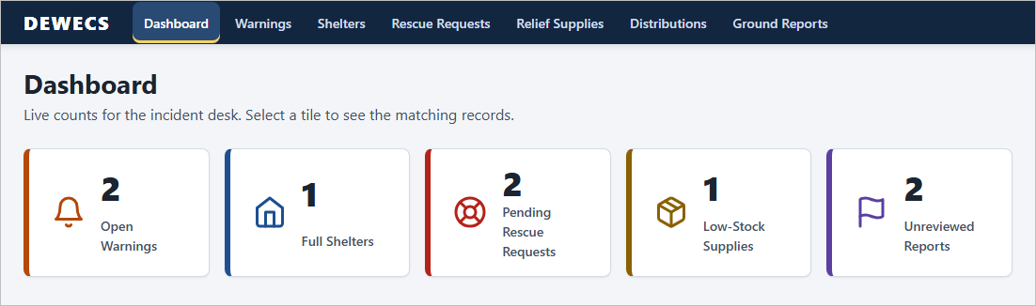
Figure C-1: Dashboard: five live counts (open warnings, full shelters, pending rescue requests, low-stock supplies, unreviewed ground reports). Each tile links to the matching list.

C.3.2 UC-01 Issue and Escalate Hazard Warning
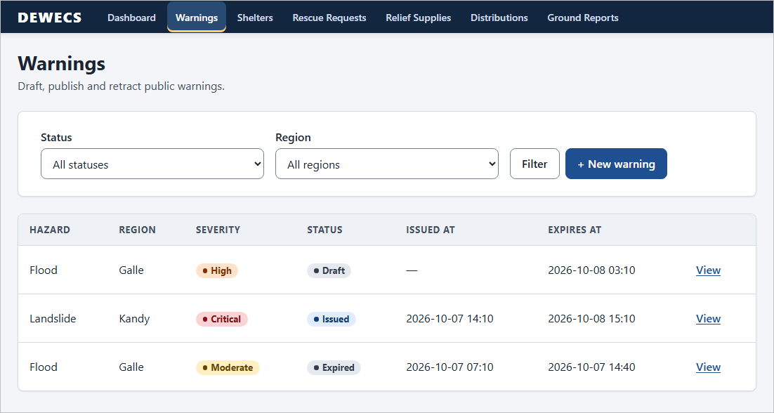
Figure C-2: UC-01, Warnings list: filter by status and region, severity and status badges. The overdue flood warning already shows Expired because the list expires overdue issued warnings when it is opened.
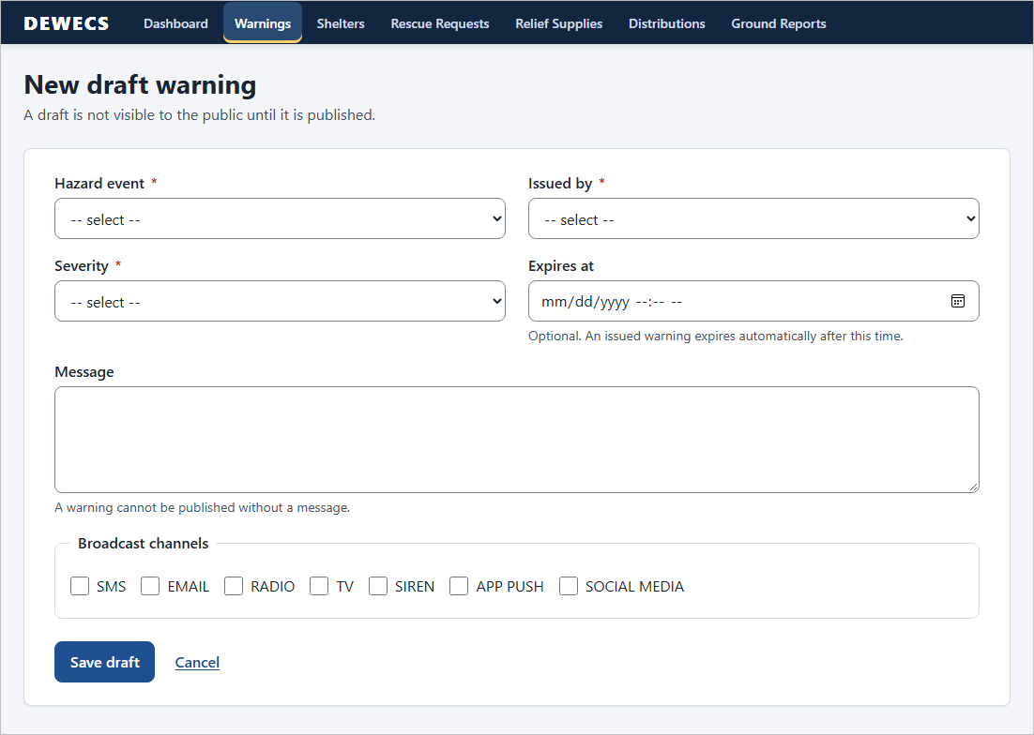
Figure C-3: UC-01, New draft warning: hazard event, issuing officer, severity, optional expiry, message and broadcast channels. A draft is not public until it is published.
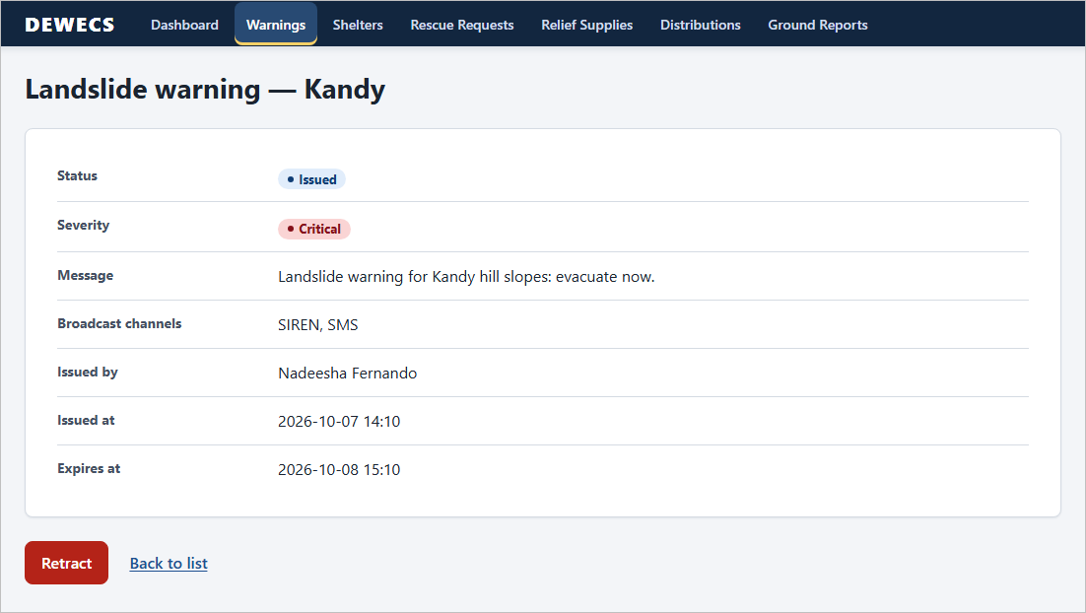
Figure C-4: UC-01, Warning detail (issued, critical): the only action offered is Retract.

C.3.3 UC-03 Coordinate Shelter and Rescue Operations
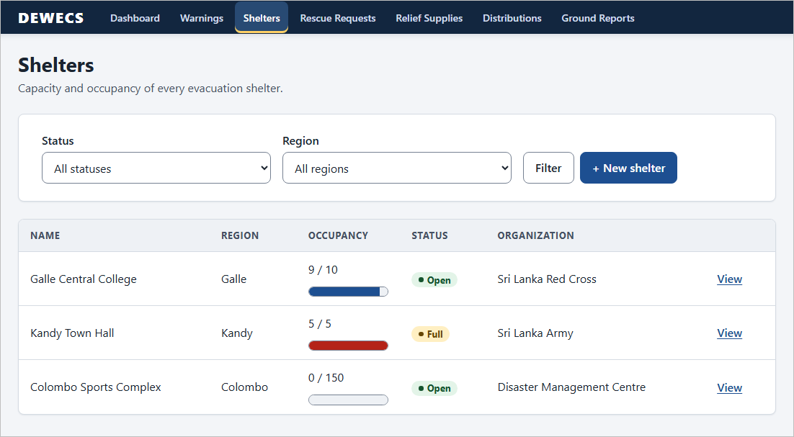
Figure C-5: UC-03, Shelters list: occupancy bars (red when full), status and owning organization.
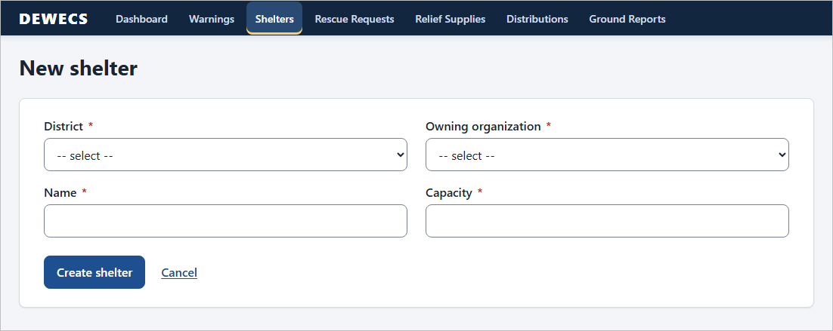
Figure C-6: UC-03, New shelter: district, owning organization, name and capacity (must be greater than zero).
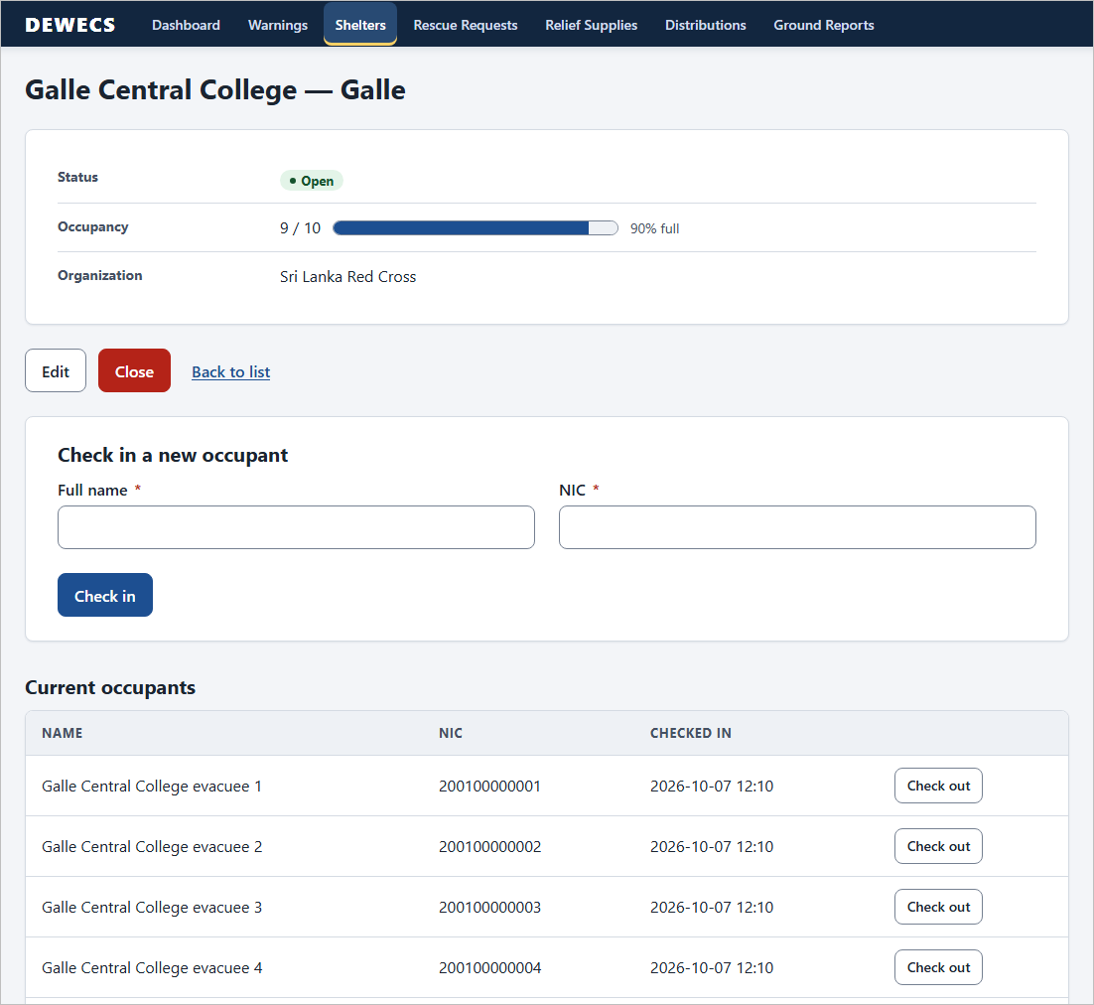
Figure C-7: UC-03, Shelter detail: occupancy, owning organization, Edit and Close, the check-in form and the current occupants with Check out (first four of nine occupants shown).
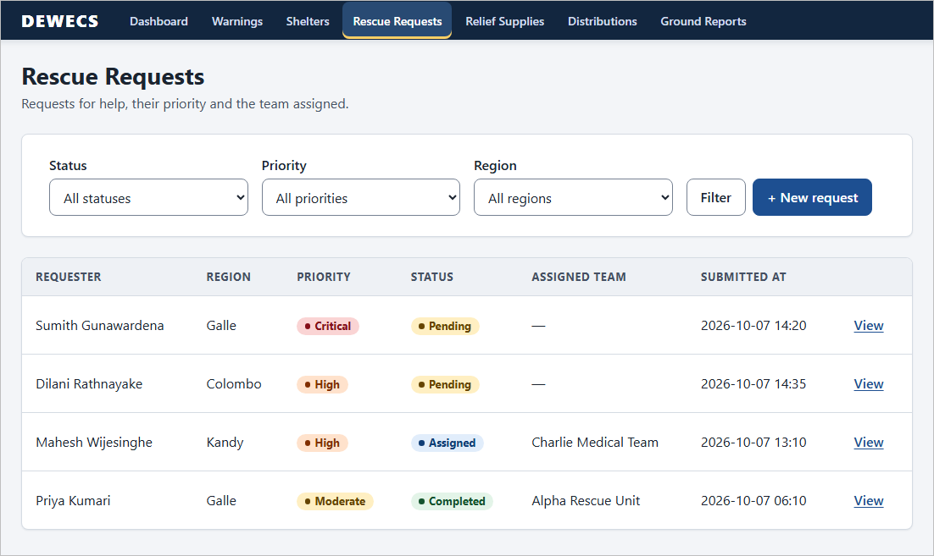
Figure C-8: UC-03, Rescue requests list: filter by status, priority and region; the assigned team appears once one is assigned.
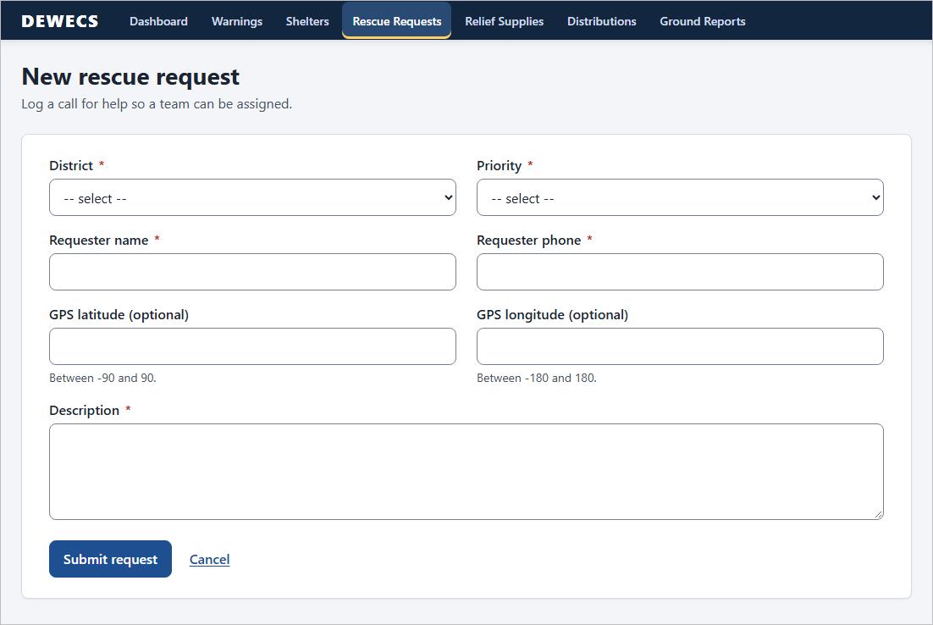
Figure C-9: UC-03, New rescue request: district, priority, requester, optional GPS (range-checked) and description.
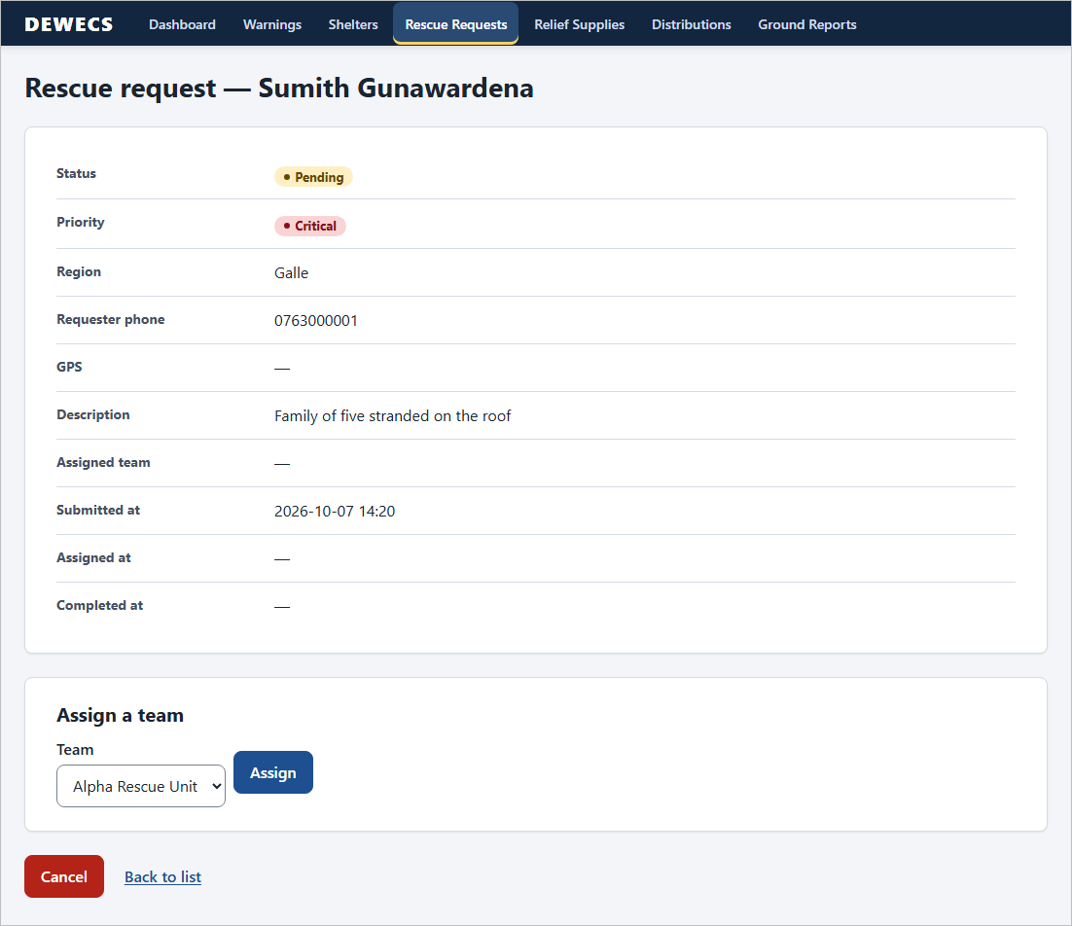
Figure C-10: UC-03, Rescue request detail (pending, critical): assign one of the available teams, or cancel.

C.3.4 UC-04 Coordinate Relief Distribution
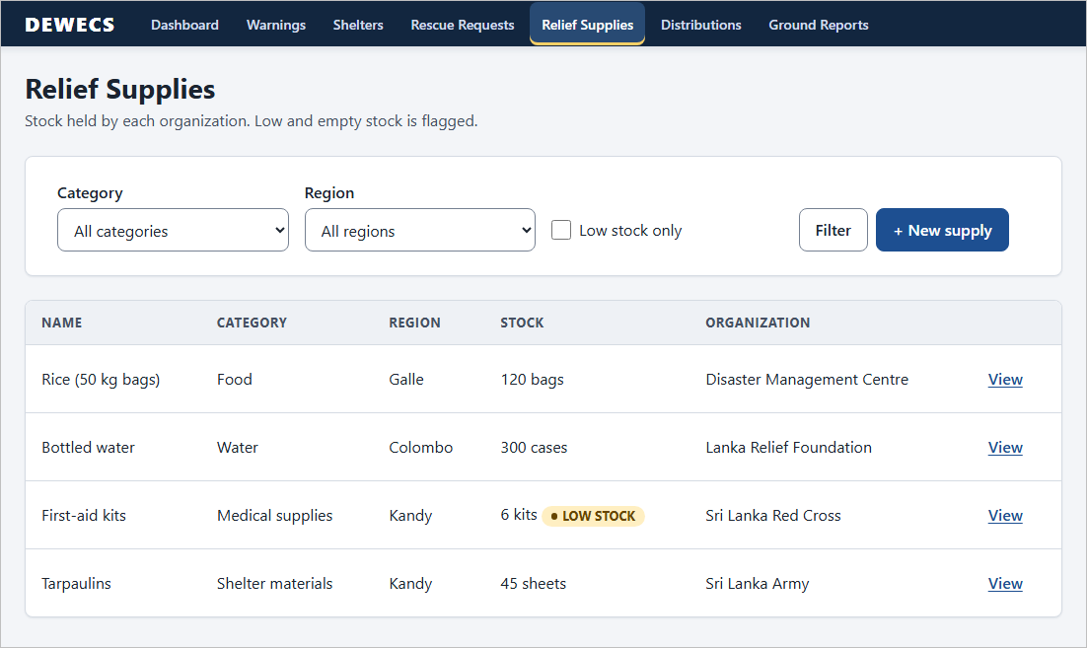
Figure C-11: UC-04, Relief supplies: stock per owning organization; stock below 10 carries a LOW STOCK flag, with a Low stock only filter.
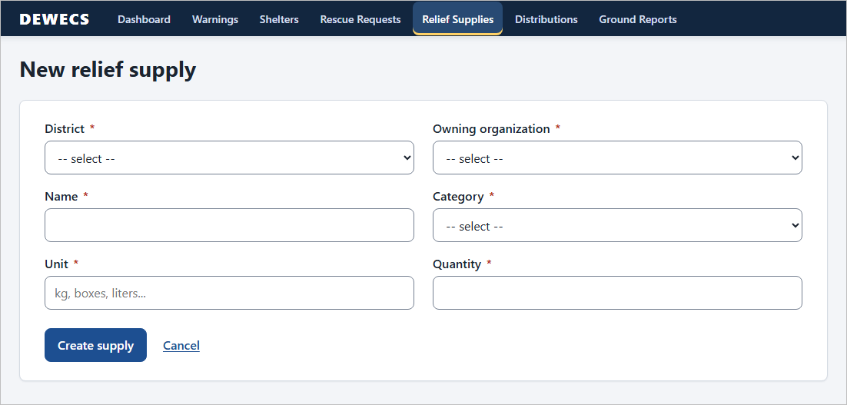
Figure C-12: UC-04, New relief supply: district, owning organization, name, category, unit and opening quantity.
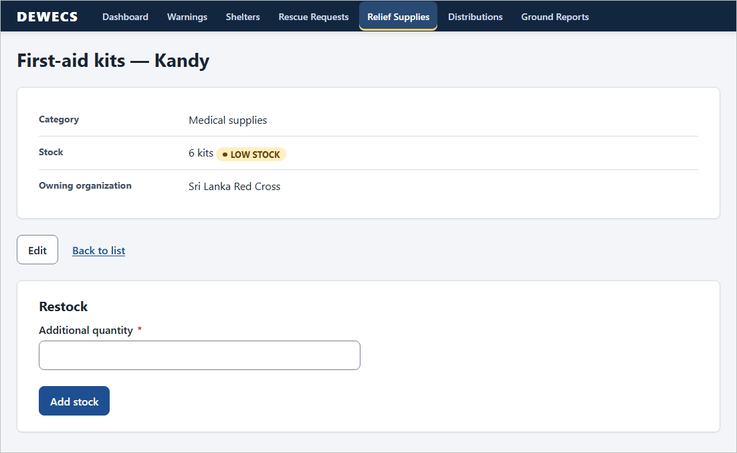
Figure C-13: UC-04, Supply detail: the low-stock flag and the Restock form (positive quantity only).
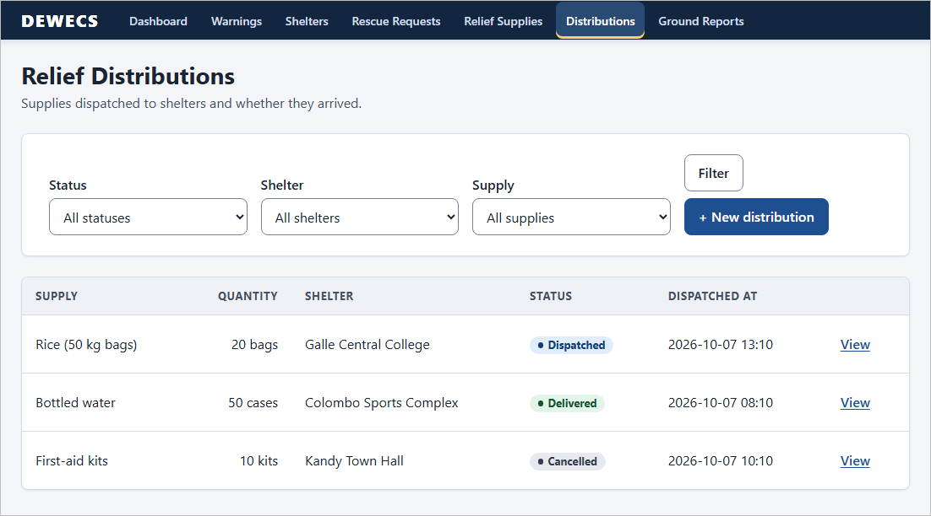
Figure C-14: UC-04, Relief distributions: dispatched, delivered and cancelled consignments; filter by status, shelter and supply.
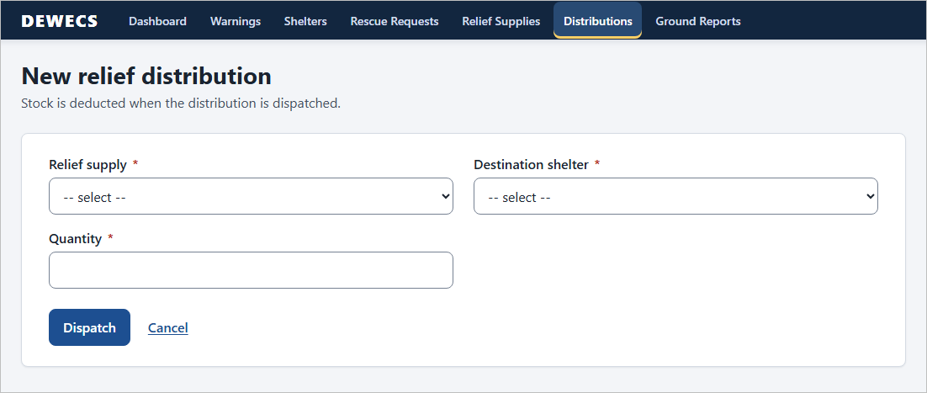
Figure C-15: UC-04, New distribution: supply, destination shelter and quantity. Stock is deducted on dispatch, and a quantity above the stock on hand is refused.
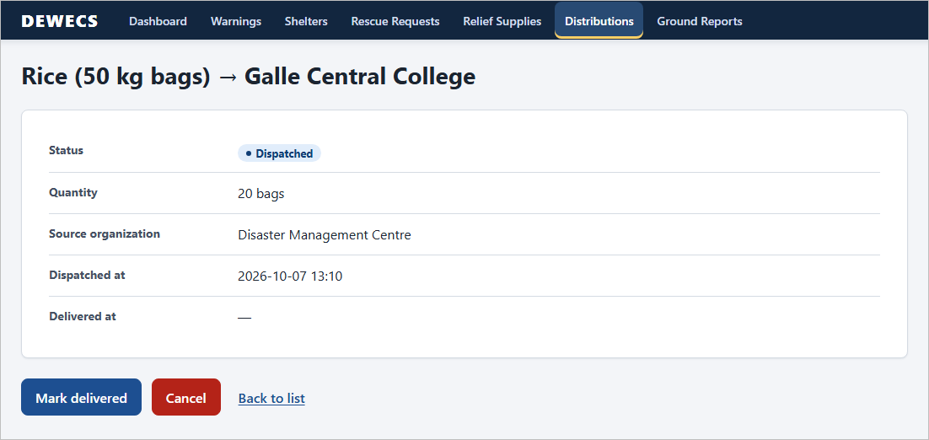
Figure C-16: UC-04, Distribution detail (dispatched): Mark delivered, or Cancel, which returns the quantity to stock.

C.3.5 UC-02 Manage Ground Reports (officer review)
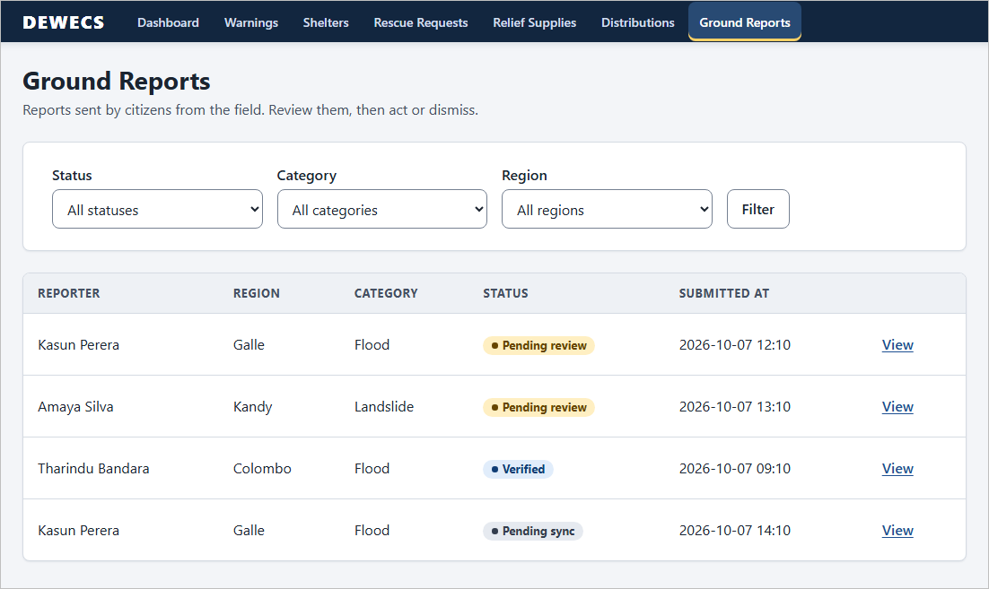
Figure C-17: UC-02, Ground reports list (officer view): filter by status, category and region; the reports come from the citizen app.
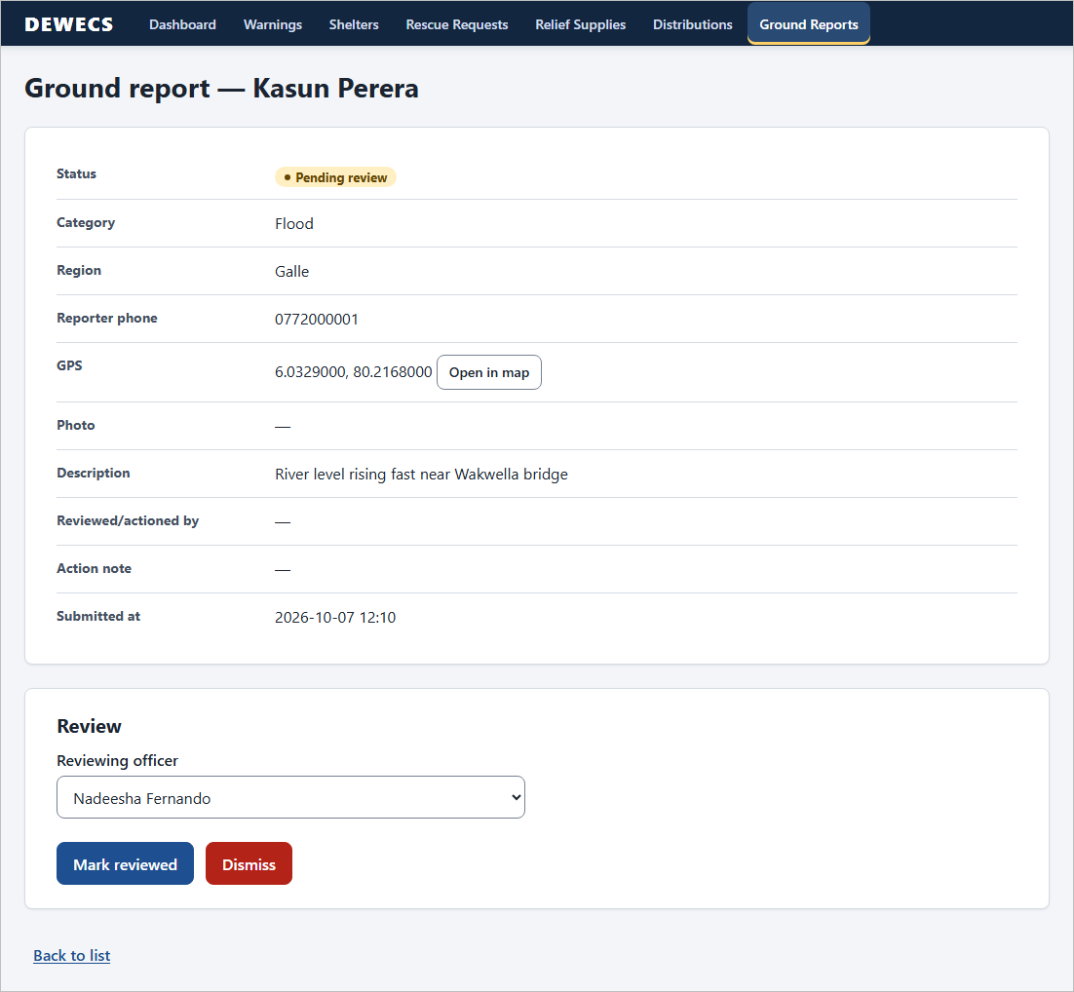
Figure C-18: UC-02, Report detail, pending review: category, region, reporter phone, GPS with Open in map, description, then Mark reviewed or Dismiss.
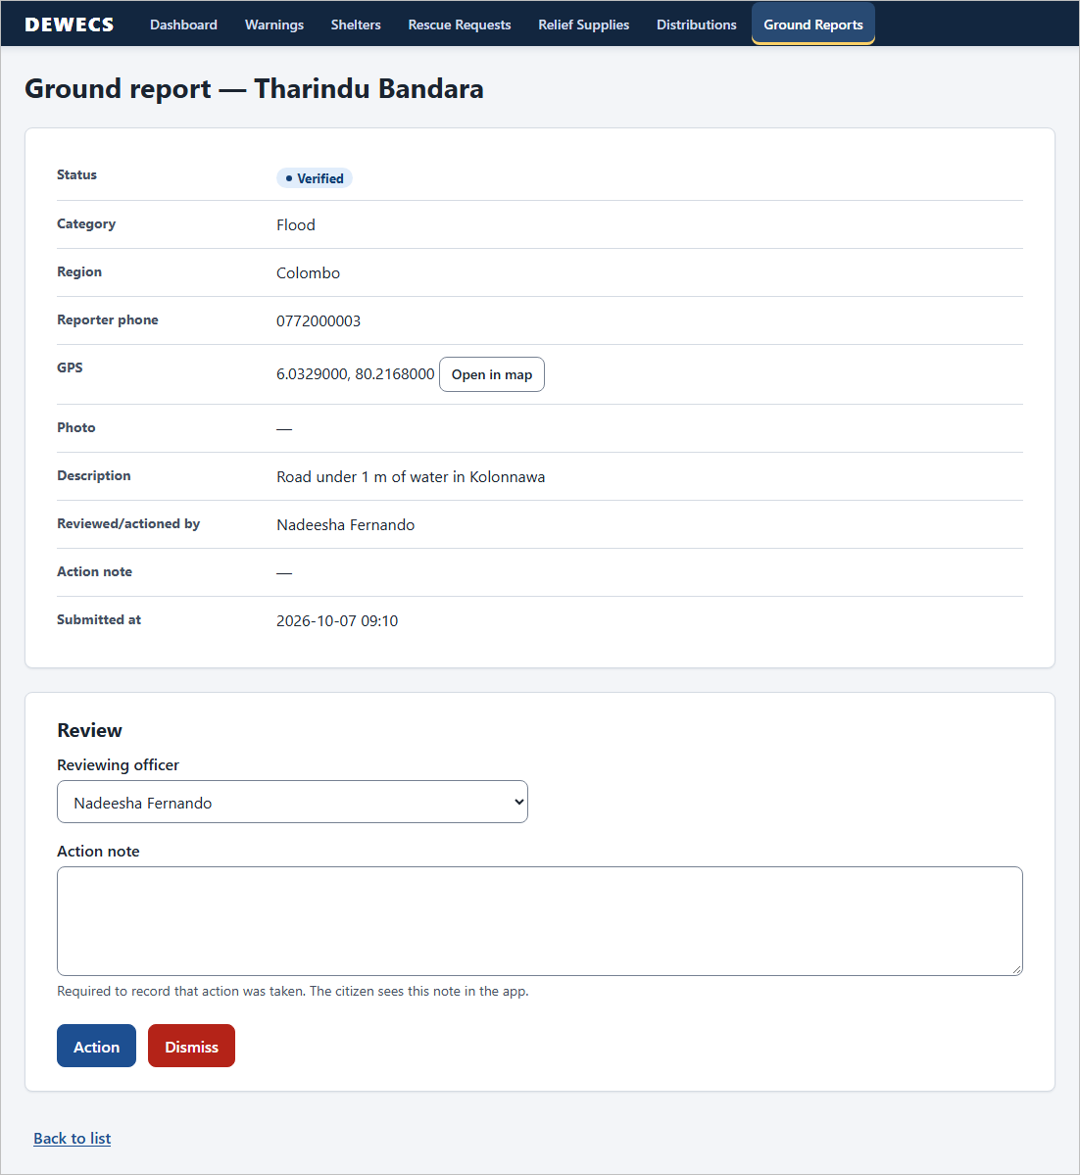
Figure C-19: UC-02, Report detail, verified: an action note is required to record that action was taken (the citizen sees it in the app); Dismiss is also available.

C.3.6 Cross-cutting screens
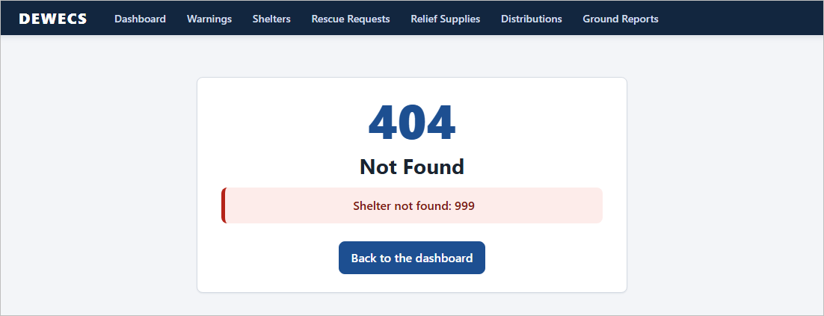
Figure C-20: Error page for an unknown record (HTTP 404) instead of a stack trace; API clients receive problem+json instead.
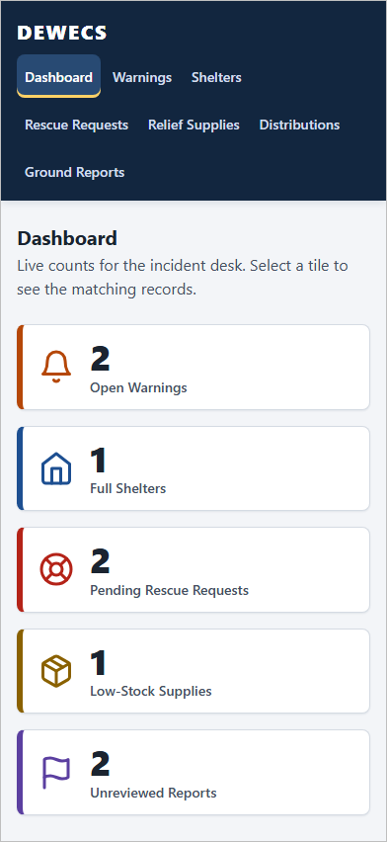 | 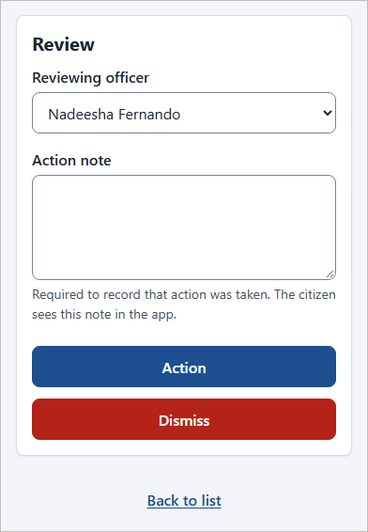
Figure C-21: Responsive layout at 390 px: the dashboard (left) and the review panel of a report page (right, cropped); the navigation wraps and the buttons become full width.

C.3.7 UC-02 Citizen app (Flutter)
[TODO — insert emulator or phone screenshots as Figures C-22 to C-27]
Run the backend with --spring.profiles.active=local, start the app (emulator address http://10.0.2.2:8080), and capture:
1. Identify screen (NIC, name, phone, district).
2. New report form with category chips and the location section.
3. A report saved while offline (“Saved on this phone.”, waiting item in My reports).
4. My reports with status chips after the sync.
5. Report detail showing the officer’s action note and Open in maps.
6. Settings with Test connection (and Demo mode if you present it).
Caption each one as “UC-02, Citizen app: …” and keep the numbers in order.

C.4 Flow description
Each flow below follows the screens in C.3 and matches the behaviour checked by the tests in C.5. Statuses are written as the screens show them.

C.4.1 UC-01 Issue and Escalate Hazard Warning (Figures C-2 to C-4)
Main flow
- The DMC officer opens Warnings (Figure C-2). Before the list is shown, any issued warning whose expiry time has passed is marked Expired.
- The officer selects + New warning (Figure C-3), picks the hazard event, the issuing officer and the severity (Low, Moderate, High or Critical), optionally sets an expiry time, writes the message (up to 2,000 characters) and ticks the broadcast channels. The warning is saved as a Draft and is not public.
- On the draft’s detail page the officer publishes it. The system refuses a blank message and a hazard event with no affected district; otherwise it stamps the issue time and sets the status to Issued.
- The warning now counts under Open warnings on the dashboard (Figure C-1), and its detail page offers Retract (Figure C-4).
Alternate flows
- Edit before publishing: only drafts can be edited; a published warning answers “Only draft warnings can be edited or published.”
- Retract: a draft or an issued warning can be retracted after a confirmation prompt; its status becomes Cancelled.
- Expiry: an issued warning past its expiry time becomes Expired the next time a warnings page is opened.
- Escalation (Part B, alternate flow A2): not implemented; see C.7.

C.4.2 UC-02 Manage Ground Reports (Figures C-17 to C-19 and the Flutter figures)
Citizen, in the Flutter app through the REST API
- On first use the citizen identifies once with NIC, full name, phone and district. The server finds or creates the citizen by NIC (201 for a new one, 200 for an existing one); the NIC is not stored on the phone.
- The citizen opens New report, chooses a category (flood, landslide, cyclone or drought), describes the hazard, sets the district and the location (GPS or typed coordinates) and may add a photo.
- Submit saves the report in the phone’s queue first and then tries to send it for up to three seconds. The app says either “Report sent.” or “Saved on this phone.”
- The sync engine sends the oldest queued report first. Every retry carries the same capture time, so a lost response cannot create a duplicate: the server answers 200 with the stored report instead of 201. The photo is uploaded afterwards and a photo failure never undoes the report.
- Temporary failures (no connection, timeout, 5xx, 408, 429) keep the report queued with the back-off from C.2.4. A report the server refuses moves to Needs attention with the server’s reason and can be edited and sent again.
- The report arrives as Pending review. My reports shows its status and, once actioned, the officer’s note.
Officer, on the web pages
- The officer opens Ground reports (Figure C-17) and filters by status, category or region.
- In a pending report (Figure C-18) the officer checks the details, the photo if there is one and the location (Open in map), selects the reviewing officer and chooses Mark reviewed (status Verified, reviewer recorded) or Dismiss (status Rejected).
- On a verified report (Figure C-19) the officer enters an action note and chooses Action; the status becomes Actioned. A blank note is refused (“An action note is required.”).
Alternate flows covered: submitting while offline (steps 3 to 5), a report the server refuses, and a server that no longer knows the citizen (the app clears its stored identity and asks to identify again). Not covered: the “More information needed” outcome is not set by any officer action, and a verified critical report does not lead to a warning (C.7, G2 and G3).

C.4.3 UC-03 Coordinate Shelter and Rescue Operations (Figures C-5 to C-10)
Shelters
- The officer opens Shelters (Figure C-5) to see capacity, occupancy and owner; a full shelter shows a red bar.
- + New shelter (Figure C-6) takes district, owning organization, name and capacity (greater than zero). A new shelter starts Open with no occupants.
- On the shelter’s page (Figure C-7) the officer checks in an evacuee by full name and NIC. Occupancy rises by one; taking the last place sets the shelter to Full, and the next check-in is refused (“Cannot check in: shelter is at full capacity.”).
- Check out frees a place, and a Full shelter returns to Open.
- Close (after a confirmation) stops check-ins (“Cannot check in: shelter is closed.”); Reopen sets Open or Full according to the occupancy.
Rescue requests
- The officer opens Rescue requests (Figure C-8) and filters by status, priority or region.
- + New request (Figure C-9) records district, priority, requester name and phone, optional GPS (latitude −90 to 90, longitude −180 to 180) and a description. The request starts Pending.
- On the request’s page (Figure C-10) the officer assigns a team. Only available teams are offered; the team becomes Dispatched and the request Assigned. Assigning a team that is not available is refused (“Team is not available for assignment.”).
- Complete (assigned requests only) frees the team and records the completion time. Cancel (pending or assigned) also frees an assigned team.
Alternate flows covered: capacity overflow, closed shelter, no team available, cancelling an assigned request. Not covered: offline resync, nearest-team selection and cross-organisation dispatch (C.7, G6).

C.4.4 UC-04 Coordinate Relief Distribution (Figures C-11 to C-16)
- The officer opens Relief supplies (Figure C-11): stock per owning organization, with a LOW STOCK flag below 10 and a Low stock only filter.
- + New supply (Figure C-12) records district, owning organization, name, category, unit and an opening quantity of zero or more.
- On a supply’s page (Figure C-13) Restock adds a positive quantity. Once stock reaches 10 the flag clears and the dashboard’s Low-stock supplies count drops.
- + New distribution (Figure C-15) takes a supply, a destination shelter and a quantity. The quantity must be positive and no more than the stock on hand; otherwise the form is shown again with a message such as “Requested quantity exceeds available stock (120 bags available).”
- On success the stock is deducted at once and the distribution is created as Dispatched, with the supplying organization taken from the supply (Figure C-14).
- On the distribution’s page (Figure C-16) Mark delivered sets Delivered and the delivery time. Cancel (dispatched only) sets Cancelled and returns the quantity to stock; a delivered distribution cannot be cancelled (“Only dispatched (not yet delivered) distributions can be cancelled.”).
Alternate flow covered: stock overdraft. A distribution carries one item.

C.4.5 Dashboard and error handling (Figures C-1, C-20, C-21)
The dashboard counts open warnings, full shelters, pending rescue requests, low-stock supplies and unreviewed reports, and the counts follow actions taken on the other screens (theFiveCountsFollowActionsTakenThroughTheScreens). An unknown record or a bad request shows the error page with the right status (Figure C-20) and never a stack trace; API clients get problem+json. The layout adapts to a 390 px phone width (Figure C-21).

C.5 Unit testing summary

C.5.1 Framework and test types
Measured with mvn -B verify on 7 October 2026: 154 tests, 0 failures, 0 errors, 0 skipped in 31 test classes (30.6 s of test time), plus the JaCoCo 0.8.12 report. Every backend test runs on in-memory H2 with the test profile, so no test needs a network and none touches the shared Neon database.
Kind | What it checks | Classes | Tests
Service tests (JUnit 5 + Mockito; photo storage uses @Temp​Dir) | Business rules of each service implementation with mocked repositories. | 10 | 74
Repository tests (@Data​Jpa​Test) | Entity mapping, the custom queries, coordinate precision (7 decimals), the NIC and replay lookups. | 6 | 14
Mapper test | Response shape of the API mapper (action note only when actioned, millisecond truncation, sorted districts). | 1 | 3
Flow tests (MockMvc, full Spring context on H2, each test rolled back) | Whole screens and API calls end to end: lifecycle, validation messages, error pages and problem+json, CORS, the contract shape. | 14 | 63
Total |  | 31 | 154

C.5.2 Coverage
JaCoCo line and branch counters, summed over the classes that implement each use case (controllers, service implementations, mappers, DTOs and validation exceptions). The assignment asks for at least 80% coverage; line coverage, the usual reading, is above that for every use case. Branch coverage is shown as well (60% to 83% by use case).
Use case | Tests | Lines covered | Branches covered | Classes counted
UC-01 Warnings | 13 | 90.3% (195/216) | 65.8% (25/38) | Warning​Controller, Warning​Service​Impl, Warning​Mapper, Warning​Form​Request, Warning​Response, Warning​Validation​Exception (6)
UC-02 web review | 12 | 97.6% (121/124) | 83.3% (15/18) | Ground​Report​Controller, Ground​Report​Service​Impl, Ground​Report​Mapper, Ground​Report​Response, Ground​Report​Validation​Exception (5)
UC-02 citizen API | 66 | 94.3% (217/230) | 79.7% (94/118) | the four API controllers, Citizen​Service​Impl, Ground​Report​Submission​Service​Impl, File​System​Photo​Storage​Service, Ground​Report​Api​Mapper, the seven dto.​api records, Citizen​Validation​Exception, two result records (18)
UC-03 Shelter and rescue | 27 | 86.5% (366/423) | 65.3% (47/72) | Shelter​Controller, Rescue​Request​Controller, both service implementations, both mappers, six DTOs, two validation exceptions (14)
UC-04 Relief distribution | 13 | 88.4% (291/329) | 60.3% (35/58) | both controllers, both service implementations, both mappers, five DTOs, Relief​Validation​Exception (12)
Dashboard and shared tests | 23 | 100.0% (30/30) | n/a | Dashboard​Controller, Dashboard​Service​Impl, Dashboard​Summary (3). The 23 shared tests cover error pages, custom queries, page rendering and the dashboard.
Whole project | 154 | 81.8% (1614/1973) | 69.7% (237/340) | All 94 JaCoCo classes, including the entities. Excluding Demo​Data​Loader (179 lines, only run by the local profile) the line coverage is 90.0%.
Classes shared by several use cases (entities, GlobalExceptionHandler, configuration) count only in the project total. Not covered by tests: behaviour specific to PostgreSQL (tests run on H2), concurrent requests, and DemoDataLoader.
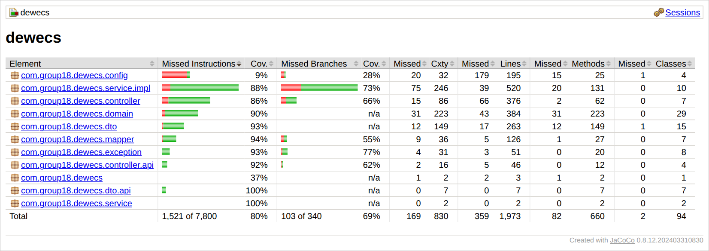
Figure C-28: JaCoCo report for the whole project (backend/target/site/jacoco/index.html): 80% instruction and 69% branch coverage overall; service.impl, where the business rules live, is at 88% and 73%.
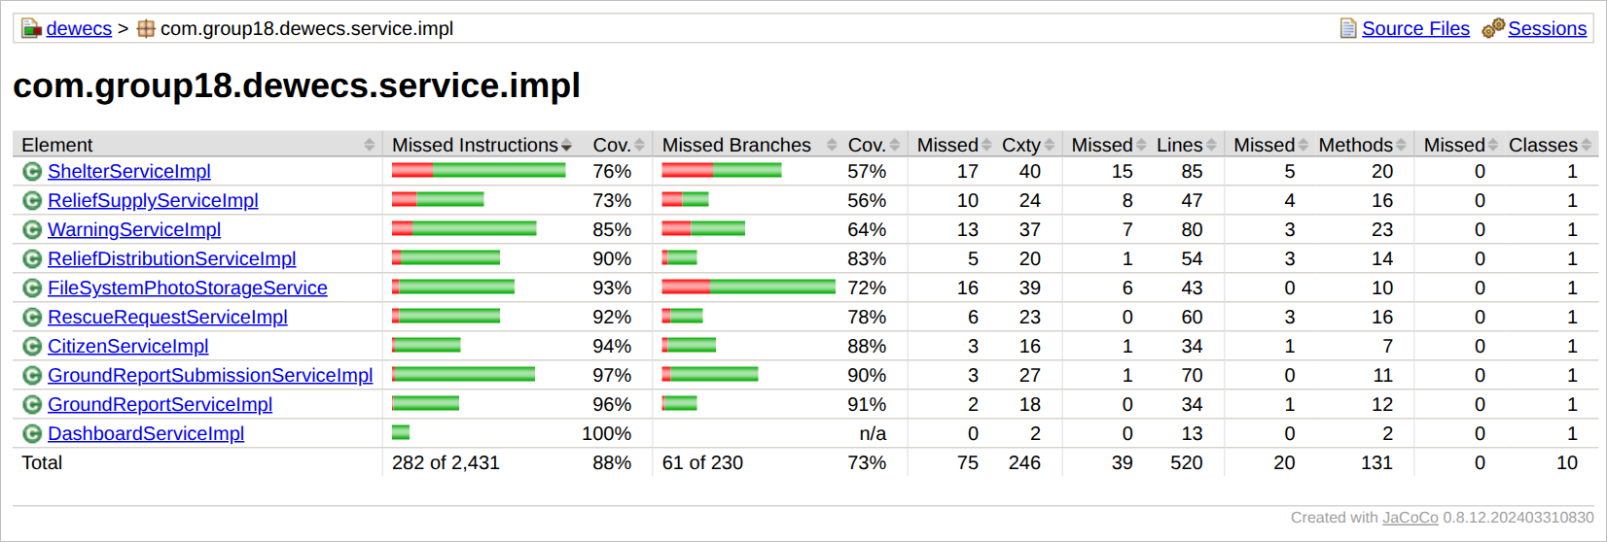
Figure C-29: JaCoCo report for com.group18.dewecs.service.impl, the package that holds every use case’s business rules.

C.5.3 What the tests check
The tests assert outcomes (new status, stock level, message, HTTP status), not just that code runs. Each row names a rule, the class that enforces it and the tests that prove it; the names are the real test method names from the surefire report.
Rule | Enforced in | Verified by (test method)
UC-01 Issue and Escalate Hazard Warning
Only a draft can be edited or published | Warning​Service​Impl.​update​Draft, .​publish | update​Draft_​on​Published​Warning_​throws​Validation​Exception  publish_​on​Already​Published​Warning_​throws​Validation​Exception  published​Warning​Cannot​Be​Edited
A message is required to publish; publishing stamps the issue time and sets Issued | Warning​Service​Impl.​publish | publish_​without​Message_​throws​Validation​Exception  draft​Without​Message​Cannot​Be​Published  create​Draft_​then​Publish_​stamps​Issued​At​And​Transitions​To​Issued
A draft or issued warning can be retracted (Cancelled) | Warning​Service​Impl.​retract | retract_​from​Issued_​sets​Cancelled  create​Edit​Publish​And​Retract​Walks​Through​The​Whole​Lifecycle
Overdue issued warnings become Expired when the list is read | Warning​Service​Impl.​list | list​With​No​Filters_​transitions​Past​Due​Issued​Warnings​To​Expired  overdue​Issued​Warning​Flips​To​Expired​When​The​List​Is​Opened
Severity must be valid | Warning​Service​Impl.​create​Draft | create​Draft_​with​Invalid​Severity_​throws​Validation​Exception  create​Without​Severity​Re​Shows​The​Form
UC-02 Manage Ground Reports: officer review
Mark reviewed moves Pending review to Verified and records the reviewer; a repeat is refused | Ground​Report​Service​Impl.​mark​Reviewed | mark​Reviewed_​from​Pending​Review_​sets​Verified​And​Reviewer  mark​Reviewed_​on​Already​Verified​Report_​throws​Validation​Exception
Action needs a verified report and a non-blank note | Ground​Report​Service​Impl.​action | action_​on​Verified​Report​With​Note_​sets​Actioned​And​Note  action_​with​Blank​Note_​throws​Validation​Exception  action_​on​Unreviewed​Report_​throws​Validation​Exception  action​Without​ANote​Is​Rejected
Dismiss rejects a report but not after it was actioned | Ground​Report​Service​Impl.​dismiss | dismiss_​from​Pending​Review_​sets​Rejected  dismiss_​on​Already​Actioned​Report_​throws​Validation​Exception
UC-02 Manage Ground Reports: citizen API
Submitting the same captured​At again returns the stored report (200) instead of a duplicate (201) | Ground​Report​Submission​Service​Impl.​submit | submit_​replay_​returns​The​Stored​Report​Unchanged​With​Created​False  whole​Flow​Submit​Replay​Photo​Get​And​List
Fields are validated; a capture time more than five minutes ahead of Sri Lanka time is refused | Ground​Report​Submission​Service​Impl.​submit | submit_​invalid​Fields_​are​Rejected  submit_​captured​At​More​Than​Five​Minutes​Ahead_​is​Rejected_​but​Exactly​Five​Is​Allowed  out​Of​Range​Coordinate​Is​AField​Error
A citizen is found or created by NIC and never overwritten; bad NIC, name or phone are refused | Citizen​Service​Impl.​identify | identify_​existing​Nic_​returns​Stored​Citizen​And​Never​Overwrites  identify_​bad​Nic​Formats_​are​Rejected  identify​Creates​Then​Finds​And​Never​Overwrites​The​Stored​Citizen
Photos: JPEG, PNG or WebP up to 5 MB, checked by content, stored under generated names, path traversal refused | File​System​Photo​Storage​Service | store_​accepts​Jpeg​Png​And​Webp​And​Names​Them​By​Content  store_​rejects​AText​File​Even​If​It​Would​Be​Called​Jpg  store_​rejects​More​Than​Five​Megabytes_​but​Accepts​Exactly​Five  load_​and​Delete_​refuse​Traversal​And​Non​Generated​Names
A photo can only be attached while the report is unreviewed | Ground​Report​Submission​Service​Impl.​attach​Photo | attach​Photo_​allowed​In​Pending​Statuses  attach​Photo_​blocked​After​Review
Every failure is problem+json with the right status; responses keep the frozen contract keys | Global​Exception​Handler, Ground​Report​Api​Mapper | wrong​Content​Type​Is415  upload​Over​The​Container​Limit​Is413​Through​The​Handler  responses​Have​The​Same​Keys​As​The​Samples  action​Note​Is​Only​Returned​When​Actioned
UC-03 Coordinate Shelter and Rescue Operations
Capacity must be greater than zero | Shelter​Service​Impl.​create | create_​with​Invalid​Capacity_​throws​Validation​Exception  zero​Capacity​Is​Rejected​And​The​Form​Is​Re​Shown
Check-in is refused when the shelter is closed or at capacity | Shelter​Service​Impl.​check​In | check​In_​when​Closed_​throws​Validation​Exception  check​In_​when​Already​At​Capacity_​throws​Validation​Exception
The last free place makes the shelter Full; a check-out makes it Open again | Shelter​Service​Impl.​check​In, .​check​Out | check​In_​last​Available​Slot_​flips​Status​To​Full  check​Out_​when​Full_​flips​Status​Back​To​Open  checking​In​Until​Capacity​Makes​It​Full​And​Check​Out​Reopens​It
Only a closed shelter can be reopened | Shelter​Service​Impl.​reopen | reopen_​on​Non​Closed​Shelter_​throws​Validation​Exception  closed​Shelter​Rejects​Check​In​And​Reopens​To​The​Right​Status
A request needs a valid priority and starts Pending | Rescue​Request​Service​Impl.​submit | submit_​creates​Pending​Request  submit_​with​Invalid​Priority_​throws​Validation​Exception
Assign needs a pending request and an available team; the team becomes Dispatched | Rescue​Request​Service​Impl.​assign | assign_​pending​Request​To​Available​Team_​sets​Assigned​And​Dispatches​Team  assign_​to​Unavailable​Team_​throws​Validation​Exception  assign_​on​Already​Assigned​Request_​throws​Validation​Exception  dispatched​Team​Cannot​Be​Assigned​To​ASecond​Request
Completing or cancelling an assigned request frees its team; only assigned requests can be completed; a completed request cannot be cancelled | Rescue​Request​Service​Impl.​complete, .​cancel | complete_​assigned​Request_​frees​Team​And​Completes​Request  cancel_​assigned​Request_​frees​Team​And​Cancels​Request  complete_​on​Pending​Request_​throws​Validation​Exception  cancel_​completed​Request_​throws​Validation​Exception
UC-04 Coordinate Relief Distribution
A distribution can never exceed the stock on hand (Part B business rule); an exact match empties the stock | Relief​Distribution​Service​Impl.​create | create_​with​Quantity​Over​Stock_​throws​Validation​Exception  create_​with​Exact​Stock_​succeeds​And​Zeroes​Stock  distributing​More​Than​The​Stock​Is​Rejected
Cancelling a dispatched distribution returns its quantity; a delivered one cannot be cancelled and gives nothing back | Relief​Distribution​Service​Impl.​cancel | cancel_​on​Dispatched​Distribution_​restores​Stock  cancel_​on​Delivered​Distribution_​throws​Validation​Exception​And​Does​Not​Restore​Stock  distribution​Deducts​Stock​Cancel​Restores​It​And​Delivered​Cannot​Be​Cancelled
Only a dispatched distribution can be delivered | Relief​Distribution​Service​Impl.​deliver | deliver_​on​Dispatched​Distribution_​sets​Delivered​At  deliver_​on​Already​Delivered​Distribution_​throws​Validation​Exception
Quantity and category must be valid; restock must be positive; low stock means fewer than 10 | Relief​Supply​Service​Impl.​create, .​restock; find​By​Quantity​Less​Than | create_​with​Negative​Quantity_​throws​Validation​Exception  create_​with​Invalid​Category_​throws​Validation​Exception  restock_​adds​To​Existing​Quantity  restock_​with​Non​Positive​Quantity_​throws​Validation​Exception  low​Stock​Queries​Use​AStrict​Less​Than
Shared
A missing record or bad request shows the error page with the right status; API clients still get problem+json | Global​Exception​Handler | missing​Record​Shows​The​Error​Page​With404  bad​Path​Variable​Is400​Not​AServer​Error  unexpected​Failure​Shows​AGeneric​Page​With500  non​Browser​Clients​Still​Get​Problem​Detail​Json

C.5.4 Citizen app tests
The Flutter app has 152 unit and widget tests (models and API fixtures, the HTTP layer with a mock client, the fake server, validators, the queue state machine, the sync engine, controllers and widgets, including a 200% text-scale run and the Android tap-target and contrast guidelines in light and dark themes) and a smoke script, tool/smoke.dart, that ran 29 checks against the real backend on the local profile. The test count is recorded in mobile/README.md and the smoke-check count in the Phase 8 log of PROGRESS_NOTES.md. VERIFY — run flutter test and dart run tool/smoke.dart once more and keep the output as evidence

C.6 GitHub repository and how to run it
Repository: https://github.com/dilmithp/se3070-group18-dewecs
Branch to mark: main. VERIFY — the Phase 6–9 work and the Flutter app are on dev and origin/dev; merge dev into main, push, and confirm the repository is public or that the marker has access
Folder | Contents
backend/​ | Spring Boot application, tests and the JaCoCo configuration (mvn from this folder).
mobile/​ | Flutter app “DEWECS Report” (Android).
doc/​ | DEMO_​SCRIPT.​md (the click path with the seeded record IDs), MOBILE_​API.​md (contract v1), api-samples/​, two Postman collections, the SQL checks for the shared database, and screenshots/​.

Run the tests and open the coverage report:
cd backend
mvn -B verify # 154 tests, WAR and JaCoCo report
The coverage report opens from backend/target/site/jacoco/index.html.
Start the application with demo data (no credentials needed):
cd backend
mvn -B -DskipTests package
java -jar target\dewecs-0.0.1-SNAPSHOT.war --spring.profiles.active=local
Open http://localhost:8080. The local profile uses in-memory H2 and DemoDataLoader, so the shared Neon database is never touched. The default and dev profiles read DB_URL, DB_USERNAME and DB_PASSWORD from the environment; real values are never committed (.env is git-ignored and .env.example holds placeholders).
Run the citizen app: start the backend as above, then cd mobile, flutter pub get, flutter test, flutter run. In Settings the server address for the Android emulator is http://10.0.2.2:8080; Demo mode runs the app against a built-in fake server.

C.7 Deviations from the corrected design and known limitations
The implementation follows Part B except where listed here.
Ref | The corrected design requires | The implementation today
G1 | UC-01, alternate flow A2: an officer can escalate an active warning (Part B, Improvement 1, point 1). | Not implemented. An issued warning can be retracted or left to expire; there is no escalate action, no severity change on an issued warning and no notification to the District Officer.
G2 | UC-02: verification ends as Verified, Rejected or Needs information. | Officers can mark a report Verified or dismiss it (Rejected). Needs information exists in the data model and as a status label in the app, but no officer action sets it.
G3 | UC-01 extension point: a verified critical ground report may trigger a new warning. | Not implemented. An officer creates the warning by hand on the Warnings page; a verified report does not lead to a draft warning.
G4 | UC-01 main flow: the warning is broadcast through the chosen channels (SMS, push, siren). | The channels are stored with the warning. Nothing is sent and no sender is mocked.
G5 | UC-05 Generate Post-Event Analysis Report, with Post​Event​Report associated to Warning/Notification and to Shelter. | Not implemented. Post​Event​Report and Report​Metric are unchanged domain classes with bare repositories.
G6 | UC-03 alternate flows: offline queue with conflict resolution on resync, nearest-team selection, cross-organisation dispatch. | Not implemented on the web: the dashboards need a connection (the citizen app is the offline-capable client). The officer picks an available team by hand and no organisation rule is applied.
Other known limitations, all documented in backend/README.md and mobile/README.md:
- No authentication or roles (excluded by the assignment); 26 TODO comments mark the protected actions. The mobile API has no login either, so anyone who knows a NIC can report as that citizen.
- No optimistic locking: two simultaneous check-ins or distributions could oversubscribe a shelter or a stock.
- Warning expiry is lazy (a warning flips to Expired when a warnings page is read), so the dashboard can briefly count an overdue warning as open.
- A distribution to a closed shelter is accepted, and a distribution carries one item.
- No screens create districts, organizations, users, hazard events, teams or citizens; the local demo data provides them. Lists are not paginated.
- The citizen app is Android only, sends reports only while it is open (no background sync) and needs the phone’s clock to be correct.

Appendix C-A AI usage log (Pathirana P P D S S)
This log follows the group report’s template (member, tool used, prompts, what was kept or changed) and can be pasted into its AI usage table. The four Claude Code prompts are reproduced word for word in Appendices C-B to C-E.
Member | Tool used | Prompt(s) | What was kept / changed
Pathirana P P D S S | Claude Code (Anthropic) | TODO — paste the Phase 1–5 prompts here. They produced the scaffold, the domain model and the four officer use cases (commits 615f7e6 and 9c802d3). | Kept: the scaffold and the four use cases, 43 tests. CONFIRM — hand edits, if any
Pathirana P P D S S | Claude (Cowork) | “bro refer this folder and note what we have done here becouse i have lost my claude code chat here” | Kept: PROGRESS_​NOTES.​md, used as the reference for every later phase. Changed: corrected against the code and updated after each phase.
Pathirana P P D S S | Claude (Cowork) | “make a next claude prompt”, then the answer “Reporting = Ground-report review” to a scoping question. | Kept: the Phase 6 prompt (Appendix C-B), run as written.
Pathirana P P D S S | Claude Code (Anthropic) | Phase 6, “Finish, harden and demo-proof (no new features)”: environment-variable datasource and profiles, demo data, flow tests, transactions, error pages, documentation. Full text: Appendix C-B. | Kept: all of it; tests rose from 43 to 83. Changed: unknown URLs and bad ids that returned 500 now return 404 and 400; credentials removed from the working tree.
Pathirana P P D S S | Claude (Cowork) | “i think this still have BE only neh that springboot one , where the fe and mobile app? is this include on that prompt”, then the answers “REST API for mobile”, “The Flutter app” and “Polish the web UI”. | Kept: the Phase 7, 8 and 9 prompts (Appendices C-C to C-E), run as written.
Pathirana P P D S S | Claude Code (Anthropic) | Phase 7, mobile REST API for ground reporting (contract v1). Full text: Appendix C-C. | Kept: seven endpoints, 71 new tests (154 in total). Changed: GPS columns widened to numeric(10,7) after a test showed rounding to two decimals; a flaky timestamp assertion led to Jackson​Config.
Pathirana P P D S S | Claude Code (Anthropic) | Phase 8, Flutter ground-reporting app in mobile/​. Full text: Appendix C-D. | Kept: the app, 152 tests, the smoke script. Changed: two bugs found by widget tests were fixed (a refresh during build; a list child that shifted the form fields).
Pathirana P P D S S | Claude Code (Anthropic) | Phase 9, web UI polish (templates and styles only, no behaviour change). Full text: Appendix C-E. | Kept: shared fragments, design tokens, readable badges, screenshots. Changed: a CSS specificity bug (plain buttons) and the “Sms/Tv” labels were fixed; no Java changed, all 154 tests still green.
Pathirana P P D S S | Claude (Cowork) | “is this ready to CSSE Assignment 02 ? and give me submission report also” | Kept: this Part C section, built from the repository, surefire and JaCoCo output. Changed: CONFIRM — your own edits and the red items

Appendix C-B Phase 6 prompt (Claude Code), verbatim
PHASE 6 — FINISH, HARDEN AND DEMO-PROOF (no new features)

CONTEXT
You are continuing the SE3070 Group 18 DEWECS backend (Spring Boot 3.5.16, Java 21, Maven,
Thymeleaf, Spring Data JPA) in this repo. The four web use cases are built and pushed:
Warning Issuance (/warnings), Shelter & Rescue (/shelters, /rescue-requests), Relief
Distribution (/relief-supplies, /relief-distributions) and Reporting = ground-report review
(/ground-reports) plus the dashboard. PostEventReport and ReportMetric are shared domain-model
classes outside my scope: leave them alone. Do not add features or use cases.
Goal: submission-ready for Assignment 02 (due Fri 9 Oct 2026, 11:59 PM) and safe to demo in the viva.

Read first: PROGRESS_NOTES.md in the repo root (rebuilt from git after I lost my earlier chat; if it
disagrees with the code, trust the code and correct the note). Then backend/pom.xml, the three
config files and the service/impl classes.

HARD RULES
1. Never print, log or commit credentials. Never connect to the shared Neon database: no running
the app with the committed datasource, no psql, no SQL against Neon. Do not start the app at
all until Stage 1 is done, and afterwards only with the `local` profile.
2. No schema changes: no new tables, columns, enum values or @Version fields. Neon is shared with
three teammates.
3. Follow the conventions in PROGRESS_NOTES.md section 5 (controller -> service interface ->
service/impl -> repository, DTO + mapper, one ValidationException per aggregate, constructor
injection, post/redirect/get with flash "message"/"error"). No Lombok.
4. All 43 existing tests must stay green. Add tests; never delete or weaken one.
5. Do not commit or push. Leave everything in the working tree for me to review.
6. Use `mvn` from backend/ (there is no wrapper). If JDK 21 or Maven is missing, stop and tell me.
7. At the end of each stage, append 2-3 lines to a "Phase 6 log" section at the bottom of
PROGRESS_NOTES.md (what changed, what is left) so nothing is lost if this session ends.

STAGE 0 - PLAN
Run `git status` (expect PROGRESS_NOTES.md untracked, and possibly the Postman JSON shown as
modified only because of line endings: leave that file alone). Then reply with a plan of at most
15 lines (stages, files you will touch, anything you are unsure about) and wait for my OK before
editing anything.

STAGE 1 - CREDENTIALS AND PROFILES
- application.properties has the Neon URL, user and password hard-coded and sets
spring.profiles.active=dev. Replace the datasource values with ${DB_URL}, ${DB_USERNAME} and
${DB_PASSWORD} (no defaults) and remove spring.profiles.active=dev.
- The default profile keeps ddl-auto=validate. `dev` becomes the opt-in schema-updating profile
(ddl-auto=update); fix its stale comment. Add a `local` profile (application-local.properties):
H2 in-memory in PostgreSQL mode, ddl-auto=create-drop, no environment variables needed. H2 must
be available at runtime for it: change its Maven scope from test to runtime and tell me.
- Every test class that boots Spring must use @ActiveProfiles("test") so nothing can ever pick up
a Neon datasource.
- Check that .env.example holds placeholders only and that .env is git-ignored.
- Do not try to rewrite git history. I will rotate the Neon password myself.

STAGE 2 - BUILD, TESTS, COVERAGE
- Run `mvn -B test`. Report tests run and failed; fix anything broken (the pom gained
<packaging>war</packaging> after the last green run).
- Run `mvn -B -DskipTests package` and tell me whether the WAR builds and starts with `java -jar`
using the local profile. Do not change the packaging without asking me.
- From target/site/jacoco/jacoco.csv report line and branch coverage overall and per package.

STAGE 3 - DEMO DATA AND END-TO-END FLOW TESTS
- Add a DemoDataLoader (@Profile("local"), CommandLineRunner, idempotent) that seeds enough to use
every screen: 3+ districts, organizations of different types, users and citizens (unique NICs),
hazard events, available rescue teams, ground reports (PENDING_REVIEW, VERIFIED, PENDING_SYNC),
supplies (one below the low-stock threshold of 10), shelters (one almost full), and a few
warnings, rescue requests and distributions in different states.
- Add MockMvc flow tests (@SpringBootTest + @AutoConfigureMockMvc, test profile, H2; they build
their own data, not the demo loader), one class per use case, covering the main path and the
main guard failures:
Warnings: create draft, edit, publish, retract; an overdue issued warning flips to EXPIRED on list.
Shelters: create, check in until FULL, check out back to OPEN, close, reopen.
Rescue: submit, assign, complete; cancelling an assigned request makes the team AVAILABLE again.
Relief: create supply, distribute (stock drops), cancel (stock returns), deliver, restock;
over-stock is rejected.
Ground reports: review, action with a note, action without a note rejected, dismiss.
Dashboard: the five counts follow the changes above.
Also assert that every list/new/detail/edit page renders (HTTP 200, no template error).
- Start the app once with the local profile and fetch each GET page with curl.exe to confirm 200.
- Fix any bug you find with a minimal, convention-following change plus a regression test.
- Write doc/DEMO_SCRIPT.md: a numbered click-path for the viva using the seeded records, with the
expected result of each step. Include only steps you verified.

STAGE 4 - HARDENING (small and easy to explain in a viva)
a) @Transactional on the service-impl methods that write more than once (relief create/cancel,
rescue assign/complete/cancel, shelter checkIn/checkOut) and on the warning list/getById path,
which writes when it expires overdue warnings. Pure reads: readOnly = true.
b) HTML-aware errors: for browser requests to the Thymeleaf controllers return a friendly
templates/error page (status, message, back link, the existing layout fragment, no stack trace)
for ResourceNotFoundException (404), a bad path variable or missing parameter (400) and
unexpected errors (500). Keep the ProblemDetail JSON for non-HTML clients. Make sure framework
exceptions (unknown URL, 405, 400) are not reported as 500. Add tests.
c) @DataJpaTest tests for the custom queries: the three search methods, findAvailable,
findByQuantityLessThan and the count methods.

ASK ME FIRST (propose, do not implement): rejecting a distribution to a CLOSED shelter; making the
dashboard's open-warnings count exclude overdue warnings; any other business-rule change; changing
the packaging; adding any dependency.

STAGE 5 - DOCS
- Rewrite backend/README.md to match reality: layout, environment variables (PowerShell and
IntelliJ examples), the three profiles and exactly how to run each (including running `dev` once
against Neon, only after I confirm with my teammates), tests and coverage, the four use cases
with their routes, SOLID notes with real examples from this code, known limitations.
- Create doc/neon-schema-check.sql from the read-only checks in PROGRESS_NOTES.md section 8
(never run it).
- Add a concise CLAUDE.md (40 lines max): how to run tests, the hard rules above, the conventions,
and a pointer to PROGRESS_NOTES.md.
- Update PROGRESS_NOTES.md (config, known gaps, test count, coverage) and extend the viva
cheat-sheet (section 14) with answers that name the exact classes and tests.

STAGE 6 - FINAL CHECK AND REPORT
- Run `mvn -B clean verify`: green, WAR built.
- Scan every tracked and new file for secrets (npg_, neon.tech, a literal password value);
application.properties must contain none.
- Confirm the Postman collection in doc/ still matches the routes.
- Final report (max 25 lines): files changed (git status), test count and coverage, how to run each
profile, decisions I should review, and what is left for me to do by hand (rotate the Neon
password and tell the team, run doc/neon-schema-check.sql in the Neon SQL editor, push).

WORKING STYLE
After I approve the plan, run stages 1-6 in order. Pause only for an "Ask me first" item or if a
stage fails twice. After each stage give a 3-5 line summary. If time gets short, the priority order
is Stages 1, 2, 3, 6, then 5, then 4.

Appendix C-C Phase 7 prompt (Claude Code), verbatim
PHASE 7 - MOBILE REST API FOR GROUND REPORTING (backend only, no new use cases for officers)

CONTEXT
You are continuing the SE3070 Group 18 DEWECS backend (Spring Boot 3.5.16, Java 21, Maven, Thymeleaf, Spring Data JPA; code in backend/, base package com.group18.dewecs). The four officer web use cases are built (Warning Issuance, Shelter & Rescue, Relief Distribution, Reporting = ground-report review at /ground-reports) and Phase 6 was meant to harden them. The fifth use case, ground hazard reporting, is a Flutter phone app: citizens submit reports and officers review them on the existing /ground-reports pages. This phase adds the JSON API that app calls. The contract below is final: build exactly that.
Goal: a small, stable, well-tested API, ready for Assignment 02 (due Fri 9 Oct 2026, 11:59 PM) and safe to demo.

Read first: PROGRESS_NOTES.md in the repo root (if it disagrees with the code, trust the code and fix the note), sections 5 (conventions), 6 (routes), 8 (Neon drift) and the "Phase 6 log" at the bottom. Then GroundReport, RescueRequest, Citizen, User, District, GroundReportService and its Impl and test, GroundReportController, GlobalExceptionHandler, CitizenRepository, GroundReportRepository, pom.xml and the config files.

=== DEWECS MOBILE API - CONTRACT v1 (frozen: Phase 7 implements it, Phase 8 consumes it) ===

GENERAL
- Base path /api/v1. JSON in and out, UTF-8. No authentication in v1 (known limitation: anyone who knows a NIC can report as that citizen).
- Timestamps: ISO-8601 local date-time in Sri Lanka time (UTC+05:30, no daylight saving), no offset suffix, at most millisecond precision, for example 2026-10-07T14:03:11.123. Clients convert from UTC by adding 5 h 30 min.
- Coordinates: JSON numbers, decimal degrees (WGS84). The server rounds to 7 decimals.
- Errors: RFC 7807 problem JSON. Always present: status, title, detail. Bean-validation failures on body fields (400) also carry fieldErrors, an object of field name -> message. Other 400s (rules checked in the service: a NIC that is invalid after normalisation, a photo upload that is not allowed in the report's status, an unsupported, empty or over-5-MB image) carry status, title and detail only. 413 appears only if the servlet container's multipart limit trips before the 5 MB check. Parse error bodies as JSON whatever media type they declare.
- Report statuses: PENDING_SYNC, PENDING_REVIEW, VERIFIED, REJECTED, NEEDS_INFO, ACTIONED. A new report starts as PENDING_REVIEW. Clients must tolerate unknown values by showing them as raw text.

REPORT OBJECT (returned by every report endpoint)
{"id":101,"citizenId":42,"districtId":1,"districtName":"Colombo","category":"FLOOD",
"description":"River is overflowing near the bridge","gpsLat":6.9271234,"gpsLng":79.8612345,
"photoUrl":null,"status":"PENDING_REVIEW","actionNote":null,"submittedAt":"2026-10-07T14:03:11.123"}
- photoUrl is null, or a path starting with /api/v1/photos/ (prepend the server base URL), or (legacy rows only) any other text, which clients treat as "no displayable photo".
- actionNote is non-null only when status is ACTIONED. No reviewer names, phone numbers or other personal data are ever returned.

ENDPOINTS
1. GET /api/v1/reference-data
200 {"districts":[{"id":1,"name":"Colombo"}],"categories":["FLOOD","LANDSLIDE","CYCLONE","DROUGHT"]}
Districts are sorted by name (case-insensitive); categories are the HazardType values.

2. POST /api/v1/citizens/identify
body {"nic":"199012345678","fullName":"Nimal Perera","phone":"0771234567","districtId":1}
201 when a citizen was created, 200 when the NIC already existed (stored name, phone and district are never overwritten).
response {"id":42,"fullName":"Nimal Perera","districtId":1,"districtName":"Colombo","created":true}
Rules: nic is trimmed, upper-cased and must match ^(\d{9}[VX]|\d{12})$ (old 9-digit-plus-letter or new 12-digit Sri Lankan NIC); fullName is trimmed, 1-120 characters, not blank; phone matches ^\+?[0-9][0-9 -]{7,14}$ ; districtId must exist (404 otherwise).

3. POST /api/v1/ground-reports
body {"citizenId":42,"districtId":1,"category":"FLOOD","description":"River is overflowing near the bridge",
"gpsLat":6.9271234,"gpsLng":79.8612345,"capturedAt":"2026-10-07T14:03:11.123"}
201 + Location header /api/v1/ground-reports/101 + report object. photoUrl cannot be set here.
200 + the stored report, unchanged, when a report with the same citizenId, category and capturedAt already exists (idempotent replay, so retries are safe).
Rules: citizenId, districtId, category, description, gpsLat, gpsLng are required; capturedAt is optional (default: now, which also means no replay detection); category is one of the reference-data categories (case-insensitive); description is trimmed, 1-2000 characters; gpsLat -90..90; gpsLng -180..180 (deliberately no Sri Lanka bounding box: emulators default to California); capturedAt may not be later than the server's now + 5 minutes; submittedAt = capturedAt when given. Unknown citizenId or districtId -> 404.

4. POST /api/v1/ground-reports/{id}/photo
multipart/form-data with one part named file: JPEG, PNG or WebP (checked by content, not by the client's Content-Type), 1 byte to 5 MB.
200 + report object with photoUrl set. Uploading again replaces the photo. Allowed only while the status is PENDING_SYNC, PENDING_REVIEW or NEEDS_INFO (otherwise 400). Unknown id -> 404.

5. GET /api/v1/ground-reports/{id}
200 report object, or 404.

6. GET /api/v1/citizens/{id}/ground-reports?page=0&size=20
200 {"items":[report objects],"page":0,"size":20,"totalItems":57,"totalPages":3}, newest first (submittedAt desc, id desc). A page below 0 becomes 0; size is clamped to 1..50 (default 20). Unknown citizen -> 404.

7. GET /api/v1/photos/{filename}
200 image bytes with the matching image/* type, Cache-Control public with max-age one day, X-Content-Type-Options nosniff. Filenames are server-generated (a UUID plus .jpg, .png or .webp); any other name -> 404.

CLIENT RULES (for the Flutter app)
- Create capturedAt once, when the user taps Submit, and resend the identical value on every retry.
- POST /ground-reports answering 200 or 201 means the report is stored. Then upload the photo, if any. A failed photo upload never undoes the report.
- Retry later on: network error, timeout, 5xx, 408, 429. Do not retry automatically (needs the user): 400, 404, 405, 413, 415 and every other status.
- Responses carry no charset: decode the body bytes as UTF-8 (never as Latin-1) and send requests as UTF-8 with Content-Type application/json.
- Addresses of the dev machine: Android emulator http://10.0.2.2:8080 ; physical phone http://<laptop LAN IP>:8080 ; or run adb reverse tcp:8080 tcp:8080 and use http://localhost:8080.
=== END OF CONTRACT v1 ===

HARD RULES
1. Never print, log or commit credentials. Never connect to the shared Neon database: no running the app with a Neon datasource, no psql, no SQL against Neon. Start the app only with the `local` profile from Phase 6 Stage 1. If the Phase 6 log does not show that stage as done, do not start the app at all: do everything else, skip the smoke run in Stage 6 and tell me. Until that stage is done application.properties still holds the Neon credentials, so read the application*.properties files only through a filter that hides the datasource, username, password and url lines. Scan for secrets by pattern only and never type a real password into a command or print it.
2. Every test that boots Spring uses @ActiveProfiles("test") (H2). A test must never be able to see a Neon datasource.
3. No schema changes: no new tables, columns, enum values or @Version fields; the shared Neon database belongs to four people. The only mapping change allowed is the precision/scale annotation in Stage 1 (with the form range check that goes with it), and its Neon side is a SQL file that I run myself.
4. Follow PROGRESS_NOTES.md section 5: controller -> service interface -> service/impl -> repository, DTO + mapper, constructor injection, no Lombok; services take plain arguments (ids, strings, BigDecimal) and return entities; reuse GroundReportValidationException and ResourceNotFoundException for the report rules, and add CitizenValidationException for the citizen rules (one per aggregate, mapped to 400 in GlobalExceptionHandler).
5. Do not change the constructor or behaviour of GroundReportServiceImpl: its test builds it with three arguments. New behaviour goes in new services.
6. All existing tests (43, plus whatever Phase 6 added) stay green. Add tests; never delete or weaken one.
7. Never log NIC numbers, phone numbers or report text at INFO level or above.
8. Do not commit or push. Never run git checkout, switch, stash, reset, clean, restore or rebase: my earlier phases are uncommitted in the working tree. Do not reformat or re-save files you do not need to change (keep their line endings) and check git diff --stat at the end.
9. Use mvn from backend/ (there is no wrapper). If JDK 21 or Maven is missing, or a dependency cannot be downloaded, stop and tell me. Start the app only as a background process whose PID you keep and stop it by that PID (on Windows: taskkill /PID <pid> /T /F); never kill processes by image name, because IntelliJ and other Java programs may be running.
10. Contract v1 is frozen. If you think it needs a change, stop and ask me: the Flutter app is being built against it.
11. At the end of each stage append 2-3 lines to a "Phase 7 log" section at the bottom of PROGRESS_NOTES.md (what changed, what is left) so nothing is lost if this session ends.

STAGE 0 - PLAN
Run git status --short and keep its output (at the end, report only the changes you caused). Run git fetch, then inspect the other branches read-only with git branch -r, git ls-tree -r origin/<branch> and git grep <pattern> origin/<branch> for existing REST or mobile code: a teammate may already have an API or a Flutter project that writes ground reports. If so, show me and stop. Check the Phase 6 log. Then reply with a plan of at most 15 lines (stages, files you will create or touch, anything you are unsure about) and wait for my OK before editing anything.

STAGE 1 - GPS PRECISION (a bug I found while reading the entities)
GroundReport and RescueRequest declare gpsLat and gpsLng as BigDecimal with no @Column(precision, scale). As far as I know Hibernate 6 then creates numeric(38,2), which silently rounds every coordinate to 2 decimals (about 1 km). Do not assume it: prove it.
a) Write a @DataJpaTest (test profile) that saves a GroundReport and a RescueRequest with lat 6.9271234 and lng 79.8612345, flushes, clears the persistence context, reloads and asserts the coordinates come back unchanged (compare with compareTo). Also read NUMERIC_PRECISION and NUMERIC_SCALE of the four columns from INFORMATION_SCHEMA.COLUMNS. Run it BEFORE touching the entities and show me the real output. If it already passes, tell me and skip the rest of this stage.
b) Neon will keep the old columns until I alter them, so I need to know that the new mapping still starts on an old schema. While the entities are still unchanged, create an old-style schema in a file-based H2 database: from backend/, run the app with the local profile (this needs the Phase 6 local profile; if it is missing skip b) and d) and tell me) and these command-line overrides, with the URL in single quotes because of the semicolon: '--spring.datasource.url=jdbc:h2:file:./target/gpscheck;MODE=PostgreSQL' --spring.jpa.hibernate.ddl-auto=create. Stop the app.
c) Add @Column(precision = 10, scale = 7) to the four fields. Re-run the test until it is green. A coordinate of 1000 or more would now overflow the column and the rescue-request web form has no range check, so also add @DecimalMin and @DecimalMax (-90..90 and -180..180, with messages in the style of the other form messages) to gpsLat and gpsLng in RescueRequestFormRequest, with a test, so bad input gives a form error instead of a database error.
d) Rebuild if you run a packaged jar or war, then start the app again against the same file with --spring.jpa.hibernate.ddl-auto=validate. It must start. (As far as I know Hibernate's validate compares column types only, never precision or scale, so this proves that startup is unaffected, not that coordinates keep 7 decimals.) If it does not start, stop and tell me: it would mean the Neon columns have to be altered before anyone starts the app. Delete the target/gpscheck files afterwards.
e) Write doc/neon-gps-precision.sql: a read-only check query on information_schema.columns for ground_reports and rescue_requests (gps_lat, gps_lng), then four ALTER TABLE ... ALTER COLUMN ... TYPE numeric(10,7) statements, with a comment saying I run it in the Neon SQL editor after telling my teammates, that coordinates that were already rounded cannot be recovered, and that until it runs Neon keeps storing 2 decimals (a POST response still shows 7 because it returns the saved object, but a later GET or a replay shows 2). Never run it.

STAGE 2 - SERVICES AND PHOTO STORAGE (no controllers yet)
- CitizenRepository.findByNicIgnoreCase. GroundReportRepository: a paged query for one citizen's reports (newest first) and the lookup for the replay check (citizen, category, submittedAt).
- A Clock bean in config/ (zone Asia/Colombo) used only by the new submission service so tests can fix "now". Do not change how the existing services read the time (note in the known gaps that they still use LocalDateTime.now() in the JVM zone).
- CitizenService + CitizenServiceImpl: identify(nic, fullName, phone, districtId) returns a small result (citizen + created flag). Normalise and validate exactly as in the contract. If two requests race on a new NIC (DataIntegrityViolationException on the unique column), catch it and re-read the existing citizen. identify must NOT be @Transactional as a whole: a rollback-only transaction would break the re-read (PostgreSQL answers "transaction aborted", H2 throws UnexpectedRollbackException). Let each repository call use its own transaction and catch the exception outside any transaction.
- GroundReportSubmissionService + impl (new; the review service stays untouched): submit(citizenId, districtId, category, description, gpsLat, gpsLng, capturedAt) returning the report plus a created flag; attachPhoto(reportId, ...); listForCitizen(citizenId, page, size) returning a Page. Every rule in the contract, including rounding to 7 decimals (HALF_UP), truncating capturedAt, and the default now, to milliseconds before saving and before the replay lookup, status PENDING_REVIEW, and the status rule for photos. Replay detection is check-then-insert, not a database constraint (no schema change allowed): document that limitation. Because two overlapping retries could insert two rows, the replay lookup must return the oldest match (a findFirst...OrderByIdAsc query or a List), never a single-result Optional that would throw on every later retry. @Transactional on writes and readOnly on reads, matching what Phase 6 Stage 4 did.
- PhotoStorageService + FileSystemPhotoStorageService: directory from the property dewecs.photos.dir (default uploads/ground-reports relative to the working directory; add uploads/ to .gitignore; the local profile may point it into java.io.tmpdir). store(...) checks size and type by magic bytes (JPEG FF D8 FF, PNG 89 50 4E 47 0D 0A 1A 0A, WebP "RIFF" + 4 bytes + "WEBP"), ignores the client's file name and Content-Type, names the file UUID + extension and returns that name. load(name) returns a Resource only for names that match the generated pattern and resolve inside the directory (no path traversal). delete(name) applies the same name-pattern and containment check as load(name) and is otherwise best effort. Create the photo directory on first use. Attaching a photo: write the new file first, update the row, then delete the old file, but only when the old photoUrl starts with /api/v1/photos/ (legacy photoUrl values are arbitrary text); if the row update fails, delete the new file.
- application.properties: spring.servlet.multipart.max-file-size=6MB and max-request-size=7MB (Spring's default is 1MB), slightly above the 5 MB rule so the service's own check normally answers first.
Tests (Mockito and @TempDir, no Spring context unless noted): every rule in the contract, including: new versus existing citizen, NIC normalisation and bad formats, the unique-NIC race, unknown district or citizen, future capturedAt with a fixed Clock, replay returns the stored report with created=false, rounding to 7 decimals, photo allowed or blocked by status, paging clamps, a text file renamed .jpg rejected, more than 5 MB, empty file, names such as ../x, ..\x and absolute paths. Plus a @DataJpaTest for the new repository queries.

STAGE 3 - API LAYER
- First create doc/api-samples/*.json (reference-data, citizen, report, report-list, problem, problem-with-field-errors) straight from the contract; the shape test below reads them from ../doc/api-samples (tests run with backend/ as the working directory).
- Controllers under controller/api (@RestController, @RequestMapping("/api/v1")) whose simple class names end in ApiController (GroundReportApiController, CitizenApiController, ReferenceDataApiController, PhotoApiController: the same simple name as a web controller would clash as a Spring bean name), DTOs under dto/api (request classes with Bean Validation messages, response classes), a GroundReportApiMapper. Do NOT reuse the web GroundReportResponse: it contains the reporter's phone number and the reviewer's name. GET /ground-reports/{id} uses the existing GroundReportService.getById; the districts come from the existing listDistricts, sorted by name case-insensitively in the mapper (test the order). The mapper truncates submittedAt to milliseconds on output (older rows hold microseconds; test with a nanosecond value).
- Error handling for /api/**: everything is a JSON ProblemDetail (with fieldErrors for validation) using the statuses of the contract: malformed JSON 400, missing or wrongly typed parameter 400, wrong method 405, wrong content type 415, upload over the container limit 413, unknown URL 404, unexpected error 500 with no stack trace and no internal message. GlobalExceptionHandler has a catch-all Exception handler that turns framework exceptions into 500: if Phase 6 Stage 4 already fixed that, reuse it; otherwise fix it now for the whole app. Preferred way: extend ResponseEntityExceptionHandler. Careful: it already maps MethodArgumentNotValidException, HttpMessageNotReadable, HttpRequestMethodNotSupported, HttpMediaTypeNotSupported, NoResourceFound, type mismatch and missing parameter, so override its handleXxx methods instead of adding a second @ExceptionHandler for any of them, otherwise Spring fails at startup with an ambiguous mapping. Choose JSON or HTML by request path (/api/) inside the global advice, not with basePackages or annotation selectors: a selector-scoped advice never sees unknown URLs or multipart-limit errors, because no controller has been chosen yet. Paths under /api/ must always get JSON, even when a browser asks with Accept: text/html; the Thymeleaf pages keep the HTML error page from Phase 6.
- Optional CORS, off by default: property dewecs.api.cors.allowed-origin-patterns (empty = no CORS headers), applied to /api/** only. The local profile sets http://localhost:*,http://127.0.0.1:* so a Flutter web build can call it during development.
- GET /api/v1/photos/{filename} streams the file with the headers from the contract.
Tests (@SpringBootTest + @AutoConfigureMockMvc, test profile, H2; the test profile shares one named in-memory database with every other Spring test, so each test builds its own data with unique NICs and leaves none behind, through a @Transactional test class or cleanup in @AfterEach; add dewecs.photos.dir=${java.io.tmpdir}/dewecs-test-photos to application-test.properties so tests never write into backend/uploads): the whole flow (reference-data; identify created, then existing; submit 201; replay 200 with the same id; upload a photo; GET report shows photoUrl; GET photo returns the same bytes with image/png; list newest first with the paging fields); every failure in the contract as a ProblemDetail (400 with fieldErrors, 404s, 405, 415, malformed JSON, unknown /api URL, Accept: text/html on an /api/v1 URL still gives JSON; 413 through the handler, for example with a small test controller that throws MaxUploadSizeExceededException); a contract-shape test that compares the JSON key sets of each response with the files in doc/api-samples (keys only, not values); CORS on and off.

STAGE 4 - WEB SIDE (tiny)
- templates/ground-reports/detail.html: when photoUrl starts with /api/v1/photos/ show it as an <img> (alt text, a class in style.css that limits the width, wrapped in a link to the full image); otherwise keep today's text. No other template changes in this phase.
- Re-run the Phase 6 flow tests (they must still pass) and add one test that a report with a photo renders the <img>.

STAGE 5 - DOCS
- doc/MOBILE_API.md: the contract copied exactly, error semantics, retry guidance, one worked example per endpoint (on Windows PowerShell write the JSON body to a file and use curl.exe --data-binary "@body.json" -H "Content-Type: application/json" (the quotes matter: an unquoted @body.json is PowerShell splatting), or Invoke-RestMethod; multipart with curl.exe -F "file=@photo.png;type=image/png"), how to run the backend for the app (local profile, 10.0.2.2, LAN IP, adb reverse), and known limitations (no authentication, NIC not verified, photos on local disk, no push updates, replay detection is check-then-insert).
- doc/api-samples/*.json already exist from Stage 3: re-check them against the final responses. Phase 8 copies them.
- doc/DEWECS-mobile-api.postman_collection.json: a NEW collection for the seven endpoints (variables baseUrl, citizenId, reportId; no secrets). Do not edit the existing collection.
- PROGRESS_NOTES.md: section 6 (routes), the test count, the config (photos directory, multipart limits, CORS property), known gaps; extend the viva cheat-sheet (section 14) with answers that name classes and tests: why a new submission service instead of extending the review service, how retries are safe without a schema change, why photos are validated by content, why coordinates are numeric(10,7).
- backend/README.md: a "Mobile API" section. CLAUDE.md (if Phase 6 created it): add the new rules in at most 5 lines and keep the file within Phase 6's 40-line limit.

STAGE 6 - FINAL CHECK AND REPORT
- Run mvn -B clean verify: green. Report tests run and failed, and the coverage of the new classes.
- If Phase 6 Stage 1 is done: start the app with the local profile and walk the real flow once with curl.exe or Invoke-RestMethod: reference-data, identify, submit, replay (same capturedAt, expect 200 and the same id), upload a tiny valid PNG, fetch the report and the photo, list; upload a file of about 6.5 MB and expect a JSON 413; then open /ground-reports and /ground-reports/{id} and confirm the report and its <img> show on the officer pages. If port 8080 is busy use --server.port=8089. Stop the app afterwards and make sure no java process you started is still running.
- Scan every new and changed file for secrets by pattern only (npg_, neon.tech, password\s*=\s*[^$\s]); never type the real password into a command. Compare git status --short with the Stage 0 output: only intended files may differ.
- Final report (max 25 lines): files changed, test count and coverage, the API as implemented and any deviation from the contract, decisions I should review, and what is left for me to do by hand (run doc/neon-gps-precision.sql after telling the team; give my Flutter teammate doc/MOBILE_API.md; push).

ASK ME FIRST (propose, do not implement): ordering the web ground-report list newest first (the current query has no ORDER BY); keeping Citizen records out of the staff drop-downs (listUsersForSelection returns every User, so citizens created by the app will show up in the reviewer list on /ground-reports/{id} and in the Issued by list of the warning form); any contract change; authentication or API keys; rate limiting; any new dependency (OpenAPI/Swagger, Tika, Spring Security).

WORKING STYLE
After I approve the plan, run stages 1-6 in order. Pause only for an ask-first item, a failed experiment in Stage 1, or if a stage fails twice. After each stage give a 3-5 line summary. If time gets short, the priority order is Stages 1, 2, 3, 6, then 5, then 4.

Appendix C-D Phase 8 prompt (Claude Code), verbatim
PHASE 8 - FLUTTER GROUND-REPORTING APP (new folder mobile/)

CONTEXT
SE3070 Group 18 DEWECS, a disaster early-warning and emergency coordination system for Sri Lanka. The Spring Boot backend in backend/ (officer web dashboards) is done. The fifth use case is ground hazard reporting: a citizen's phone app. You are building that app as a Flutter project in mobile/ of this repo, against the REST contract below (Phase 7 implements it in backend/; it may or may not be in the working tree yet).
Use this prompt only if I am the one building the app. Stage 0 checks that nobody else has already started one.
Goal: a working, demonstrable app for Assignment 02 (due Fri 9 Oct 2026, 11:59 PM) that behaves well with poor connectivity, because that is the real situation in a disaster.
What it does: the citizen identifies once (NIC, name, phone, district), then reports a hazard (category, description, GPS, optional photo). Reports are saved on the phone first and sent when a connection exists (offline-first, safe to retry). The citizen can follow the status of past reports while officers review them on the web dashboard.

Read first: PROGRESS_NOTES.md in the repo root (section 2 for the project context, section 14 for the viva cheat-sheet you will extend) and, if they exist, doc/MOBILE_API.md and doc/api-samples/.

=== DEWECS MOBILE API - CONTRACT v1 (frozen: Phase 7 implements it, Phase 8 consumes it) ===

GENERAL
- Base path /api/v1. JSON in and out, UTF-8. No authentication in v1 (known limitation: anyone who knows a NIC can report as that citizen).
- Timestamps: ISO-8601 local date-time in Sri Lanka time (UTC+05:30, no daylight saving), no offset suffix, at most millisecond precision, for example 2026-10-07T14:03:11.123. Clients convert from UTC by adding 5 h 30 min.
- Coordinates: JSON numbers, decimal degrees (WGS84). The server rounds to 7 decimals.
- Errors: RFC 7807 problem JSON. Always present: status, title, detail. Bean-validation failures on body fields (400) also carry fieldErrors, an object of field name -> message. Other 400s (rules checked in the service: a NIC that is invalid after normalisation, a photo upload that is not allowed in the report's status, an unsupported, empty or over-5-MB image) carry status, title and detail only. 413 appears only if the servlet container's multipart limit trips before the 5 MB check. Parse error bodies as JSON whatever media type they declare.
- Report statuses: PENDING_SYNC, PENDING_REVIEW, VERIFIED, REJECTED, NEEDS_INFO, ACTIONED. A new report starts as PENDING_REVIEW. Clients must tolerate unknown values by showing them as raw text.

REPORT OBJECT (returned by every report endpoint)
{"id":101,"citizenId":42,"districtId":1,"districtName":"Colombo","category":"FLOOD",
"description":"River is overflowing near the bridge","gpsLat":6.9271234,"gpsLng":79.8612345,
"photoUrl":null,"status":"PENDING_REVIEW","actionNote":null,"submittedAt":"2026-10-07T14:03:11.123"}
- photoUrl is null, or a path starting with /api/v1/photos/ (prepend the server base URL), or (legacy rows only) any other text, which clients treat as "no displayable photo".
- actionNote is non-null only when status is ACTIONED. No reviewer names, phone numbers or other personal data are ever returned.

ENDPOINTS
1. GET /api/v1/reference-data
200 {"districts":[{"id":1,"name":"Colombo"}],"categories":["FLOOD","LANDSLIDE","CYCLONE","DROUGHT"]}
Districts are sorted by name (case-insensitive); categories are the HazardType values.

2. POST /api/v1/citizens/identify
body {"nic":"199012345678","fullName":"Nimal Perera","phone":"0771234567","districtId":1}
201 when a citizen was created, 200 when the NIC already existed (stored name, phone and district are never overwritten).
response {"id":42,"fullName":"Nimal Perera","districtId":1,"districtName":"Colombo","created":true}
Rules: nic is trimmed, upper-cased and must match ^(\d{9}[VX]|\d{12})$ (old 9-digit-plus-letter or new 12-digit Sri Lankan NIC); fullName is trimmed, 1-120 characters, not blank; phone matches ^\+?[0-9][0-9 -]{7,14}$ ; districtId must exist (404 otherwise).

3. POST /api/v1/ground-reports
body {"citizenId":42,"districtId":1,"category":"FLOOD","description":"River is overflowing near the bridge",
"gpsLat":6.9271234,"gpsLng":79.8612345,"capturedAt":"2026-10-07T14:03:11.123"}
201 + Location header /api/v1/ground-reports/101 + report object. photoUrl cannot be set here.
200 + the stored report, unchanged, when a report with the same citizenId, category and capturedAt already exists (idempotent replay, so retries are safe).
Rules: citizenId, districtId, category, description, gpsLat, gpsLng are required; capturedAt is optional (default: now, which also means no replay detection); category is one of the reference-data categories (case-insensitive); description is trimmed, 1-2000 characters; gpsLat -90..90; gpsLng -180..180 (deliberately no Sri Lanka bounding box: emulators default to California); capturedAt may not be later than the server's now + 5 minutes; submittedAt = capturedAt when given. Unknown citizenId or districtId -> 404.

4. POST /api/v1/ground-reports/{id}/photo
multipart/form-data with one part named file: JPEG, PNG or WebP (checked by content, not by the client's Content-Type), 1 byte to 5 MB.
200 + report object with photoUrl set. Uploading again replaces the photo. Allowed only while the status is PENDING_SYNC, PENDING_REVIEW or NEEDS_INFO (otherwise 400). Unknown id -> 404.

5. GET /api/v1/ground-reports/{id}
200 report object, or 404.

6. GET /api/v1/citizens/{id}/ground-reports?page=0&size=20
200 {"items":[report objects],"page":0,"size":20,"totalItems":57,"totalPages":3}, newest first (submittedAt desc, id desc). A page below 0 becomes 0; size is clamped to 1..50 (default 20). Unknown citizen -> 404.

7. GET /api/v1/photos/{filename}
200 image bytes with the matching image/* type, Cache-Control public with max-age one day, X-Content-Type-Options nosniff. Filenames are server-generated (a UUID plus .jpg, .png or .webp); any other name -> 404.

CLIENT RULES (for the Flutter app)
- Create capturedAt once, when the user taps Submit, and resend the identical value on every retry.
- POST /ground-reports answering 200 or 201 means the report is stored. Then upload the photo, if any. A failed photo upload never undoes the report.
- Retry later on: network error, timeout, 5xx, 408, 429. Do not retry automatically (needs the user): 400, 404, 405, 413, 415 and every other status.
- Responses carry no charset: decode the body bytes as UTF-8 (never as Latin-1) and send requests as UTF-8 with Content-Type application/json.
- Addresses of the dev machine: Android emulator http://10.0.2.2:8080 ; physical phone http://<laptop LAN IP>:8080 ; or run adb reverse tcp:8080 tcp:8080 and use http://localhost:8080.
=== END OF CONTRACT v1 ===

HARD RULES
1. Work only inside mobile/ (plus PROGRESS_NOTES.md). Do not edit backend/, doc/ or the Postman files. If the contract looks wrong or incomplete, stop and tell me.
2. The app talks to the Spring backend over HTTP only. It never contains database credentials or the Neon host and never connects to a database. Do not print or commit credentials; scan mobile/ for secrets at the end. No Google Maps and no Firebase (they need API keys).
3. No code generation (no build_runner, freezed or json_serializable): plain Dart classes with fromJson and toJson. Allowed packages: http, http_parser, provider, shared_preferences, geolocator, image_picker, path_provider, path, connectivity_plus, url_launcher, intl, cupertino_icons (added by flutter create) and flutter_lints (dev). Anything else: ask first.
4. Keep it simple enough to explain in a viva: Provider + ChangeNotifier, small files, no clever abstractions. Every user-visible string lives in one strings.dart (English only; do not implement Sinhala or Tamil).
5. flutter analyze must report zero issues and flutter test must be green at the end of every stage. Fix lints, do not suppress them.
6. Do not commit or push. Never run git checkout, switch, stash, reset, clean, restore or rebase: earlier phases may be uncommitted in the working tree. Do not run flutter upgrade. Do not install SDKs yourself: if Flutter, the Android toolchain or the Android licences are missing, stop and tell me what to install.
7. At the end of each stage append 2-3 lines to a "Phase 8 log" section at the bottom of PROGRESS_NOTES.md (if that file is missing, use mobile/PHASE8_LOG.md).
8. Do not reformat or re-save files you do not need to change. Save git status --short in Stage 0; at the end, compared with that, only mobile/ and PROGRESS_NOTES.md may have changed.
9. If you start the backend or any other process, start it in the background with its PID kept and stop it by that PID (on Windows: taskkill /PID <pid> /T /F); never kill processes by image name (java.exe, dart.exe, adb.exe), because IntelliJ, Android Studio and the emulator may be running.

STAGE 0 - CHECK AND PLAN
Reply with a plan of at most 15 lines and WAIT for my OK. First find out:
- flutter --version, flutter doctor -v and flutter devices. Tell me which targets can run (Android emulator or phone, Chrome, Windows desktop) and what is missing.
- git status --short (keep it), then git fetch and a read-only look at every remote branch (git branch -r, git ls-tree -r origin/<branch>, git grep pubspec origin/<branch>) and at the working tree for an existing Flutter project (pubspec.yaml, a mobile/ or app/ folder). If one exists, STOP and show me; I decide whether to extend it.
- Whether the Phase 7 API is in backend/ (controller/api, doc/MOBILE_API.md). If doc/MOBILE_API.md exists and differs from the contract above, list the differences; the doc wins only if I say so.
- Ask me which platforms to create. Default: android only. Add web only if I say so (it needs the backend's optional CORS property and cannot keep queued photos across a reload).

STAGE 1 - SKELETON
flutter create --org com.group18 --project-name dewecs_mobile --platforms <chosen> mobile. Material 3, light and dark following the system, a restrained palette for an emergency app (strong contrast, no decorative gradients), app name "DEWECS Report". Folders under lib/: config, models, api, storage, sync, state, screens, widgets, plus strings.dart. Navigation: Home (my reports), New report, Settings. Replace the generated counter test. Android: INTERNET, ACCESS_FINE_LOCATION, ACCESS_COARSE_LOCATION and <queries> entries for the https and geo VIEW intents (url_launcher on Android 11+) in the main manifest; cleartext HTTP (android:usesCleartextTraffic) only in android/app/src/debug/AndroidManifest.xml. Check that the generated .gitignore keeps build output and local.properties out of git.

STAGE 2 - API LAYER, MODELS, FAKE SERVER
- Models for the contract (District, ReferenceData, Citizen, GroundReport, ReportPage, ApiProblem) with fromJson and toJson. Unknown status strings must survive: keep the raw string and map to a label only for display.
- abstract class DewecsApi with one method per endpoint. HttpDewecsApi on package:http: base URL from settings, 15 s timeout (60 s for the photo upload), requests sent as UTF-8 JSON, every response decoded with utf8.decode(response.bodyBytes) and never with response.body (Spring sends application/json without a charset, so package:http would decode it as Latin-1 and garble Sinhala text), multipart upload for the photo, all failures mapped to one ApiException (kind: network, timeout, server or client; status; detail; fieldErrors) with a retryable getter that follows CLIENT RULES exactly.
- FakeDewecsApi implements the same interface in memory: 4 districts, 400 ms latency, replay detection on citizenId + category + capturedAt, photo attach, a few seeded reports in different statuses including ACTIONED with a note, and switches to force a network failure or a 500 so offline behaviour can be demonstrated. The Demo mode switch in Settings selects it. Demo mode is off by default. Switching it in either direction asks for confirmation and clears the stored identity, the queue, the cached reference data and the cached reports (fake ids must never reach the real backend).
- The pure-Dart layer (models + api) must not import Flutter, so it can be run with dart run.
- A time helper: now in Sri Lanka time (UTC+05:30) formatted exactly as the contract says (milliseconds, no offset).
- Tests: JSON parsing against fixtures (copy doc/api-samples/*.json into mobile/test/fixtures/ if they exist; otherwise write fixtures from the contract text and say so), HttpDewecsApi with MockClient from package:http/testing.dart (success, 4xx with fieldErrors, 5xx, timeout, malformed body; assert the method, the path, Content-Type application/json, the multipart field name file and the exact capturedAt string; include a Sinhala description and an em dash), FakeDewecsApi behaviour, the time helper.

STAGE 3 - SETTINGS, REFERENCE DATA, IDENTITY
- Settings: API base URL (default http://10.0.2.2:8080 on Android, http://localhost:8080 elsewhere; validated; persisted), a Test connection button (calls reference-data and shows the district count or a readable error), the Demo mode switch.
- Reference data is cached after every successful fetch and used offline.
- Identify screen (first run, and "Identify again" in Settings): NIC, full name, phone, district dropdown. Client-side validation mirrors the contract rules exactly (validators in one file, with tests). Calls identify and stores the returned citizen id, name and district locally; do not store the NIC after identification. Offline: show a clear message and keep the form (identifying needs one successful call).
- Home and New report require an identified citizen, otherwise they route to Identify.

STAGE 4 - NEW REPORT, OFFLINE QUEUE, SYNC (the core of the app)
Report form: category choice chips (from the cached reference data) with icons, description (multiline, counter up to 2000), district (defaults to the citizen's), location, optional photo.
- Location: a "Use my location" button with geolocator (permission flow with clear messages for denied, denied forever and location services off; 10 s timeout; falls back to the last known position), shows lat, lng and accuracy; manual latitude and longitude fields as the fallback (validated -90..90 and -180..180). No Sri Lanka bounding box (the emulator sits in California).
- Photo: camera or gallery through image_picker with maxWidth 1600 and imageQuality 80 (far below the 5 MB limit); preview and remove. On Android copy the picked file into the app documents folder so it survives while the report waits in the queue. Put this behind a small PhotoStore interface (file-based on mobile; in-memory on web if web was chosen).
- Submit: validate, set capturedAt once (Sri Lanka time), create a QueuedReport (local id, all fields, photo path, state QUEUED), persist it immediately, trigger a sync, go back to Home with a clear message ("Saved on this phone" or "Sent"). Double taps must not create two items.
Queue and sync engine (sync/): QueueRepository persists a JSON list in shared_preferences. SyncService has a single-flight lock and processes the oldest item first: submitReport; on 200 or 201 store the server id; then uploadPhoto if there is one; then mark the item SYNCED. SENDING is never persisted: on app start any SENDING item becomes QUEUED.
- Retryable errors (ApiException.retryable) keep the item QUEUED with an attempt counter and next-attempt time (backoff 5 s, 15 s, 60 s, 5 min, then every 5 min). After a 5xx, 408 or 429 continue with the next item; stop the whole run only on a network error or timeout (the connection is down). A photo failure never undoes the report: retry it separately; a permanent photo error (400, 404, 413, 415) leaves the item SYNCED with a visible "photo could not be sent" note.
- Permanent errors on submit (400, 405, 413, 415 and any other status that is neither retryable nor the 404 case below) move the item to NEEDS_ATTENTION and show the server's detail and fieldErrors; the user can Edit and retry (this resets capturedAt to now, which is safe because nothing was stored) or Delete.
- A 404 on submit: fetch the reference data (if that fetch fails, keep the item QUEUED and retry later). If the report's districtId is still listed, the citizen is unknown (the server database was reset): clear the stored identity, route to Identify, keep the queue and rewrite citizenId on the queued items after the new identification. If the district is gone, move the item to NEEDS_ATTENTION with the server's detail. A 404 on the my-reports list triggers the same identity-reset flow. Settings shows the stored citizen's name and district, so the user can see who the app thinks they are.
- Triggers: after Submit, on app start, on connectivity change (connectivity_plus), pull-to-refresh and a "Send now" button. No background service (state this limitation in the README).
- The same capturedAt goes out on every retry, so a lost response can never create a duplicate.
Tests: SyncService with FakeDewecsApi and an in-memory queue: success, offline then online, 500 then success, 400 permanent, replay (200), photo failure after report success, 404 identity reset, single-flight, backoff schedule, ordering; the QueuedReport state machine; the validators; a widget test for the form (empty submit shows errors; a valid submit enqueues exactly one item).

STAGE 5 - MY REPORTS
Home lists newest first: queued items first (chip per state: Waiting to send, Sending, Needs attention), then items that were sent but are not yet in the fetched server list (kept locally with their server id until a refresh returns that id; a "photo could not be sent" note shows on the detail screen), then server reports from GET /citizens/{id}/ground-reports with a Load more button (page size 20) and pull-to-refresh. Status chips with a label and a colour per status, text always present: PENDING_REVIEW "Waiting for review", VERIFIED "Reviewed by officers", ACTIONED "Action taken", REJECTED "Not accepted", NEEDS_INFO "More information needed", PENDING_SYNC "Waiting to send"; unknown values are shown as received. Cache the last fetched page so the list still shows offline, with an "Offline - showing saved data" banner. Detail screen: category, description, district, coordinates with an Open in maps button (url_launcher, a geo: URI, with an OpenStreetMap URL as fallback), submitted time, status, the officers' action note only when ACTIONED, and the photo (Image.network on base URL + photoUrl when it starts with /api/v1/photos/, a placeholder otherwise; for queued items show the local file).
Tests: widget tests for the list (chips, empty state, offline banner) and the detail (action note only when ACTIONED), and the status label mapping.

STAGE 6 - POLISH AND ROBUSTNESS
Loading, empty and error states on every screen; SnackBars for outcomes; 48 dp tap targets; semantic labels on icon-only buttons; no overflow at 200 percent text scale (add a widget test); both themes; no hard-coded colours outside the theme; the app never crashes on malformed server data (show a readable error). A debug-only "Sync queue" screen listing each queued item with its state, attempts and last error is welcome, because it makes the offline demo easy to explain.

STAGE 7 - REAL BACKEND CHECK AND DOCS
- If the Phase 7 API is in backend/ and the Phase 6 local profile exists: start the backend with the local profile only (never a Neon datasource) on a spare port (--server.port=8092), then run a small mobile/tool/smoke.dart (pure Dart, uses HttpDewecsApi) against http://localhost:8092: reference-data, identify, submit, replay, photo upload (a tiny generated PNG), list. Report any mismatch with the contract. Stop the backend afterwards and make sure no java process you started is left running. If Phase 7 is not there, say so clearly in the final report: the app was verified against the fake server only.
- mobile/README.md: what the app does, architecture (one paragraph and a folder list), setup (flutter doctor, flutter pub get), running on an emulator (http://10.0.2.2:8080), on a physical phone (laptop LAN IP and the Windows firewall for port 8080, or adb reverse tcp:8080 tcp:8080), Demo mode, how offline queueing and retries work, how to run the tests, cleartext HTTP (debug only; what to change for a release APK demo and why that is a trade-off), limitations (no background sync, no authentication so after a server reset the stored citizen id may point to a different person, no map tiles, English only, photos lost on web reload if web was chosen), and a note to check the phone's clock: a phone more than 5 minutes ahead of Sri Lanka time gets a permanent 400 that Edit and retry cannot fix (show the server's detail in that case).
- PROGRESS_NOTES.md: a short "Mobile app" section (what exists, how to run it, test count, limitations) and viva cheat-sheet answers (section 14): why offline-first, how retries stay idempotent without a schema change, why capturedAt is created on the device, what Provider does here, what you would add next.
- Final run of flutter analyze and flutter test. List the dependencies you added with a one-line reason each. Scan mobile/ for secrets.
- Final report (max 25 lines): what works, verified how (fake only, or real backend), test count, dependencies added, decisions I should review, and what is left for me to do by hand.

ASK ME FIRST (propose, do not implement): any package outside the allowed list; any change to the contract; background sync (WorkManager); Sinhala or Tamil; a map view; push notifications; web as a target if I did not choose it.

WORKING STYLE
After I approve the plan, run stages 1-7 in order. Pause only for an ask-first item or if a stage fails twice. After each stage give a 3-5 line summary. If time gets short, finish in this order: Stages 1, 2, 3, 4, 5, then the README and smoke run of Stage 7, then Stage 6. A smaller app that works end to end beats a bigger one that does not.

Appendix C-E Phase 9 prompt (Claude Code), verbatim
PHASE 9 - WEB UI POLISH (Thymeleaf pages only, no behaviour changes)

CONTEXT
SE3070 Group 18 DEWECS backend (Spring Boot 3.5.16, Java 21, server-rendered Thymeleaf, code in backend/). The officer dashboards work but look like unstyled prototypes. Today there are 19 templates under backend/src/main/resources/templates (dashboard.html, fragments/layout.html and 17 list, form and detail pages for warnings, shelters, rescue-requests, relief-supplies, relief-distributions and ground-reports; plus error.html if Phase 6 added it), one static/css/style.css of about 140 lines, a hard-coded nav fragment, a copied <head> and flash-message block in every page, raw enum names on screen (PENDING_REVIEW), raw timestamps (2026-10-06T14:02:11.123456), no <html lang>, no viewport meta, and a .button class that is used but never defined.
Goal: a clean, consistent, accessible, responsive UI that looks credible in the Assignment 02 viva (due Fri 9 Oct 2026, 11:59 PM) without changing what the system does.

Read first: PROGRESS_NOTES.md in the repo root (sections 4 to 6, plus the Phase 6 and Phase 7 logs if they exist), doc/DEMO_SCRIPT.md if it exists, then every template and style.css.
Prerequisite: Phase 6 Stages 1 and 3 (the local profile, and MockMvc flow tests that render every page). The 43 older tests never render a template, so those flow tests are the safety net for this phase. If they are missing, stop and tell me; do not start the app against Neon.

HARD RULES
1. Presentation only. You may change files under src/main/resources/templates and src/main/resources/static, add fragments, and add one small vanilla JS file. Do not touch Java sources under src/main, pom.xml or the properties files. Tests: only to fix an assertion on presentation text, and list every such edit in the final report.
2. Everything the server sees stays identical: URLs, HTTP methods, th:action targets, form field names, th:field bindings, request parameters. The Phase 6 flow tests and doc/DEMO_SCRIPT.md depend on them. Keep visible button and link labels unless you update doc/DEMO_SCRIPT.md in the same stage; the same goes for any on-screen text its expected results quote (status wording, date format).
3. No CDNs, web fonts, icon fonts, JS frameworks or new dependencies. System font stack, plain CSS with custom properties, inline SVG for the few icons you need. At most one JS file (static/js/app.js, under 80 lines, no libraries). Every page must still work with JavaScript off; only the confirm dialogs may depend on it.
4. Never print or commit credentials and never connect to the shared Neon database. Run the app only with the `local` profile, on a spare port (--server.port=8091), as a background process whose PID you keep; stop it by that PID (on Windows: taskkill /PID <pid> /T /F) and never kill processes by image name, because IntelliJ and other Java programs may be running.
5. mvn -B test must be green at the end of every stage. Do not commit or push. Never run git checkout, switch, stash, reset, clean, restore or rebase: earlier phases may be uncommitted in the working tree. Keep each file's line endings, save git status --short in Stage 0 and compare at the end.
6. At the end of each stage append 2-3 lines to a "Phase 9 log" section at the bottom of PROGRESS_NOTES.md.

STAGE 0 - PLAN
Run git status --short and keep its output, read the files above and note anything unusual in the templates. Reply with a plan of at most 15 lines, including the design direction in 3-4 lines (palette, type, density), and wait for my OK. Default direction if I say nothing: calm and high-contrast, deep navy top bar, white cards on a light grey background, severity colours LOW green, MODERATE amber, HIGH orange, CRITICAL red, and status colours that are never the only signal (there is always a text label).

STAGE 1 - FOUNDATIONS
- fragments/layout.html becomes a small library of parameterised fragments: head(title) (charset, viewport, title, stylesheet, an inline SVG favicon as a data URI so /favicon.ico stops answering 404); nav(active) (the active link gets aria-current="page"; pass the active section as a fragment parameter, do not inspect the request URL inside the template); flash (message and error, with role="status" and role="alert"); pageHeader(title, subtitle); badge(value), which maps an enum value to a CSS class and a human label (PENDING_REVIEW -> Pending review) and is used for every status, severity and priority shown on screen. Every th:replace must pass every parameter its fragment declares (Thymeleaf fails at render time otherwise): when you are done, grep all templates, error.html included, for calls that pass too few.
- Convert all templates to use them: no duplicated <head> or flash blocks any more, <html lang="en">, one <main id="main"> per page, a skip-to-content link.
- Rebuild style.css around design tokens (:root custom properties for colour, spacing scale, radius, shadow, type scale), a centred container (max 1100px), visible :focus-visible rings and prefers-reduced-motion. Keep every existing class name working until no page uses it; define the ones that are used but missing (.button).

STAGE 2 - COMPONENTS
Buttons (.btn with primary, secondary, danger and link variants; a link styled as a button stays a link, a button stays a button), cards, tables (header, row hover, numeric alignment, a wrapper that scrolls horizontally on narrow screens, an empty-state row with a helpful sentence), filter bars as a responsive grid, forms (labels above fields, two columns on wide screens, required markers, helper text, error state: a class on the field plus aria-invalid and aria-describedby pointing at the existing th:errors message, which needs an id added), definition lists as a labelled detail grid, stat tiles on the dashboard with an accent colour and hover and focus states, a progress bar for shelter occupancy only (<progress>, or an element with role="progressbar" and aria values; stock has no honest maximum, so supplies keep their quantity text and the LOW STOCK and OUT OF STOCK badges), flash messages, the error page.

STAGE 3 - PAGE BY PAGE
Dashboard; warnings (list, form, detail); shelters (list, form, detail with the occupancy bar and the occupant table); rescue requests (priority and status badges, assigned team); relief supplies (quantity text, keep the LOW STOCK and OUT OF STOCK badges); relief distributions; ground reports (list; detail with the photo as an image when the Phase 7 <img> exists, an "Open in map" link to openstreetmap.org built from gpsLat and gpsLng, and the review panel with clear primary, secondary and danger buttons); error.html. Format timestamps with #temporals.format using a locale-independent pattern such as yyyy-MM-dd HH:mm (month names would change with the browser language) and check that it really renders; show a dash for empty values. Destructive actions (retract warning, close shelter, cancel rescue request, cancel distribution, dismiss report) get a confirm dialog through a data-confirm attribute handled by static/js/app.js; the form still posts normally when JavaScript is off.

STAGE 4 - RESPONSIVE, ACCESSIBILITY, CHECKS
- Breakpoints for wide (900px and up), medium and narrow (under 600px): the nav wraps or collapses without JavaScript, filter bars stack, forms go single-column, tables scroll inside their wrapper.
- Accessibility: every control has a label, the tab order is logical, focus is always visible, colour is never the only carrier of meaning, text contrast is at least 4.5:1 (compute the ratio of every text/background token pair with a tiny script and show me the table), landmarks (header, nav, main), table header cells with scope.
- Start the app with the local profile and fetch every page with curl.exe: all must answer 200. Grep the returned HTML for leaked template syntax (the patterns th:[a-z]+=, \$\{ and ~\{; a bare "th:" or "__" gives false hits), for "Whitelabel" and for "Exception". Stop the app afterwards and make sure no java process you started is left running.

STAGE 5 - EVIDENCE (optional; skip silently if there is no browser)
If Microsoft Edge or Chrome is installed, take headless screenshots of every page at 1280px and 390px width into doc/screenshots/ (data comes from the local profile's demo data). msedge is usually not on PATH: look for msedge.exe (for example under C:\Program Files (x86)\Microsoft\Edge\Application) or chrome.exe and call it by its full path with --headless=new --screenshot=<file> --window-size=1280,900 --user-data-dir=<a temp folder> <url> (an already-open Edge swallows the command unless it gets its own user-data-dir). Check each PNG's pixel width: if 390 is not honoured, skip the 390 set and say so. Look at the screenshots yourself and fix what looks broken (overlaps, unreadable text, overflow). Name them <page>-1280.png and <page>-390.png.

STAGE 6 - DOCS AND FINAL CHECK
backend/README.md: a short "UI" section (the fragments, the tokens, how to add a page). PROGRESS_NOTES.md: update section 5 and add a summary to the Phase 9 log. doc/DEMO_SCRIPT.md: only if a label or an on-screen text it quotes changed. Run mvn -B clean verify: green. Final report (max 20 lines): what changed per area, the list of presentation-only test edits (if any), whether screenshots were taken, what I should review visually, and what is still plain.

ASK ME FIRST (propose, do not implement): dark mode; client-side sorting, search or pagination; embedded maps; any change that alters what is submitted or stored; any Java change (for example newest-first ordering of the lists).

WORKING STYLE
After I approve the plan, run stages 1-6 in order. Pause only for an ask-first item or if a stage fails twice. After each stage give a 3-5 line summary. If time gets short, the priority order is Stages 1, 2, 3 (dashboard, ground reports and warnings first), 4, then 5, then 6.

